# Kubernets CLUSTER SETUP ON AWS EC2 USING KUBEADM

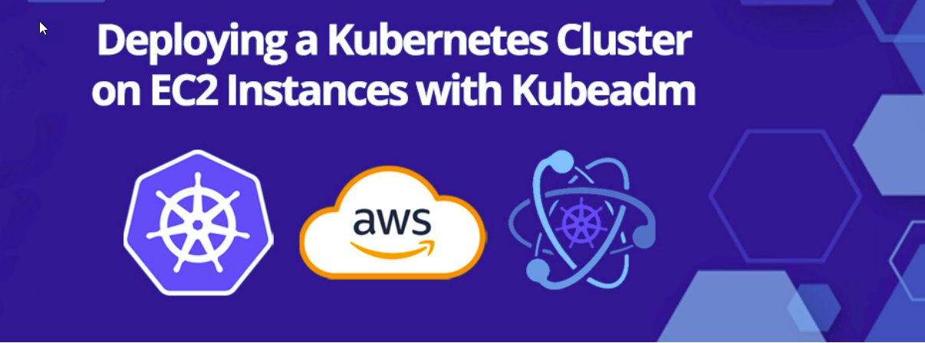

## **Why EC2 and Kubeadm?**

* **Amazon EC2** (Elastic Compute Cloud) is a web service that provides resizable compute capacity in the cloud. It’s an ideal choice for Kubernetes cluster setup and deployment due to its flexibility, scalability, and reliability.
* **Kubeadm**, on the other hand, is a tool built to provide Kubernetes administrators a simplified way to bootstrap Kubernetes clusters. It automates many of the manual processes involved in the setup of a Kubernetes cluster on AWS EC2, making it a popular choice for beginners and experts alike.
* Using kubeadm, you can create a minimum viable Kubernetes cluster that conforms to best practices and pass the Kubernetes Conformance tests.

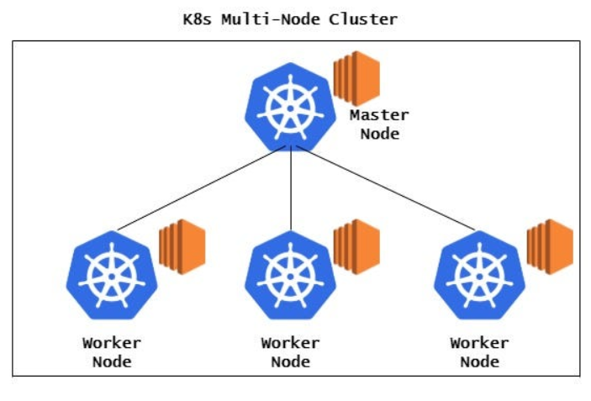

## **Prerequisites**

Before diving into the deployment process, ensure you have the following prerequisites in place:

* An AWS account with appropriate permissions to create EC2 instances.
* AWS CLI installed and configured on your local machine.
* sudo privileges
* t2.medium instance type or higher
* Basic knowledge of Kubernetes concepts and terminology.

## **Requirements**

* A compatible Linux host.
* 2 GB or more of RAM per machine (any less will leave little room for your apps).
* 2 CPUs or more.
* Full network connectivity between all machines in the cluster.
* Unique hostname, MAC address, and product_uuid for every node.
* Certain ports are open on your machines. (https://kubernetes.io/docs/reference/networking/ports-and-protocols/)
* Swap diabled. You must diable swap for the kubelet to works properly.
* A container runtime like Containerd and kubeadm on all the hosts

Official Installation doc: <https://kubernetes.io/docs/setup/production-environment/tools/kubeadm/install-kubeadm/>

## AWS Setup

* Make sure your all instance are in same **Security group**.
* Expose port **6443** in the **Security group**, so that worker nodes can join the cluster.

## Kubernetes Installation And Configuration

**Step1**. Launch 3 instances 1 **master** and 2 **worker(node)**, in this installation guide we will be installing kubeadm so we need at least t2.medium or t2.large for master meanwhile worker node can be t2.micro or any other.

Master node:

# SETTING UP MASTER NODE ON EC2

1. Search EC2 in services tab.

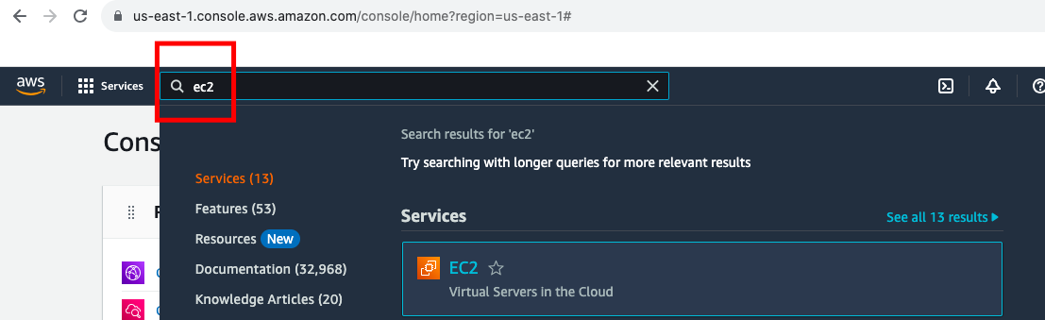

1. In the Amazon EC2 Dashboard select “Launch Instance” to create and configure your virtual machine.

1. Provide name of instance

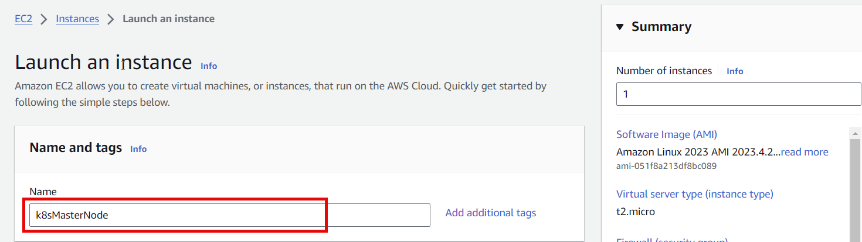

1. Select OS Image

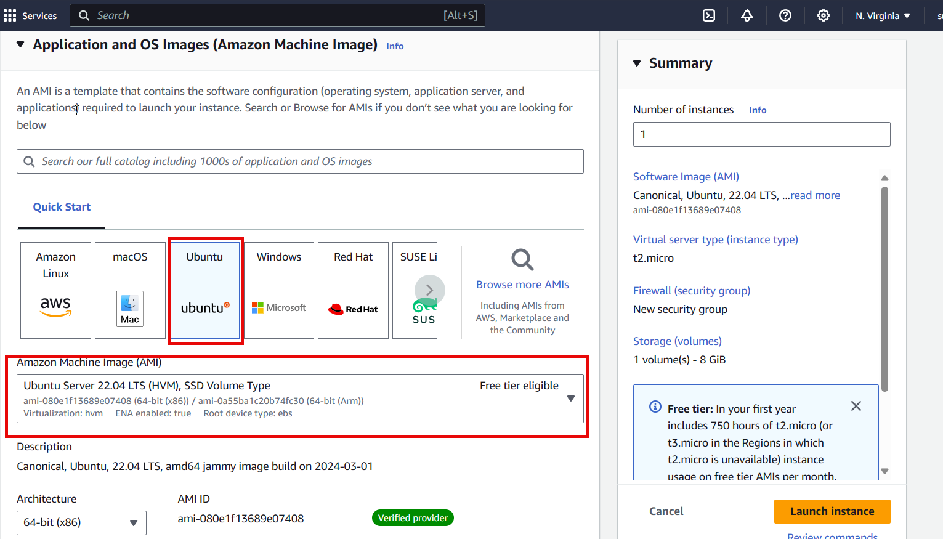

1. Select instance type as t2 medium

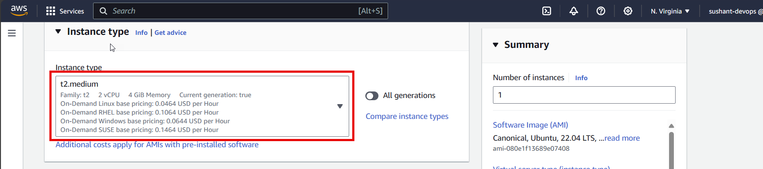

1. Select key pair (Proceed with a key pair)

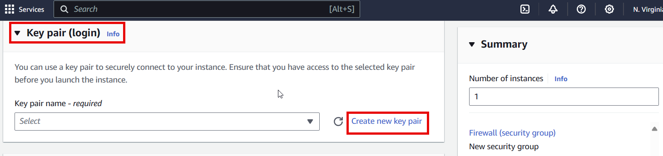

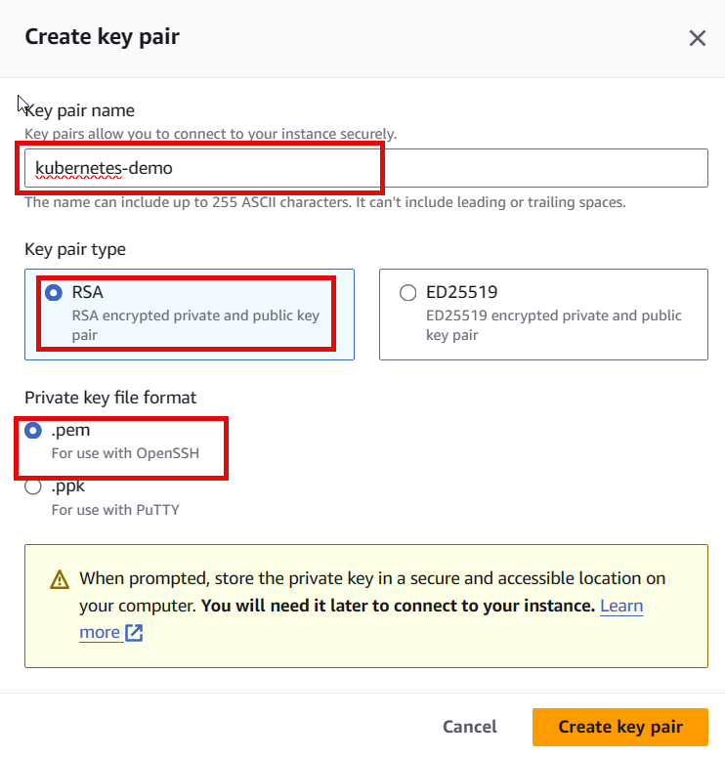

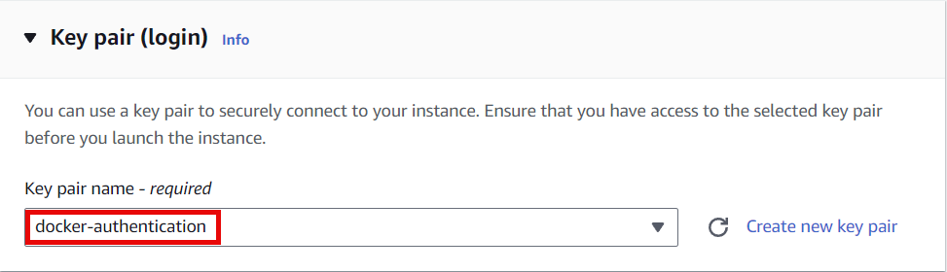

1. Create security group

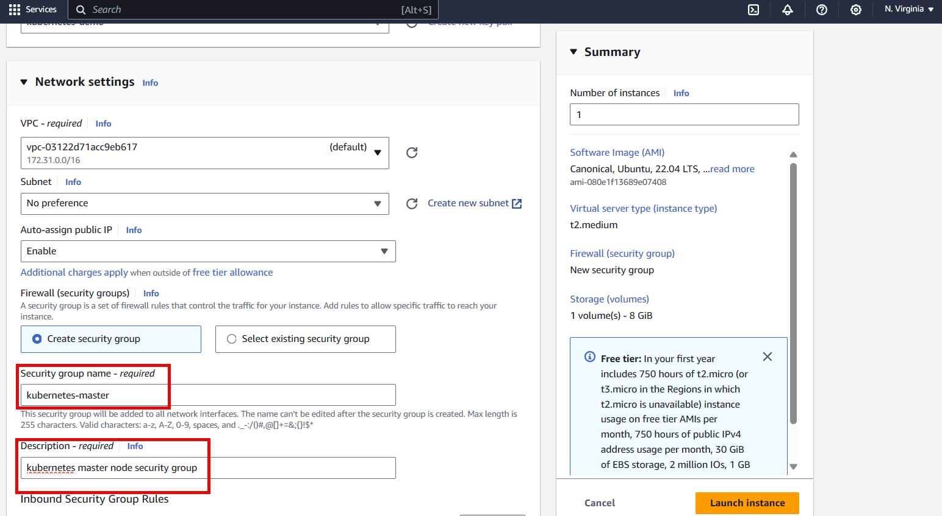

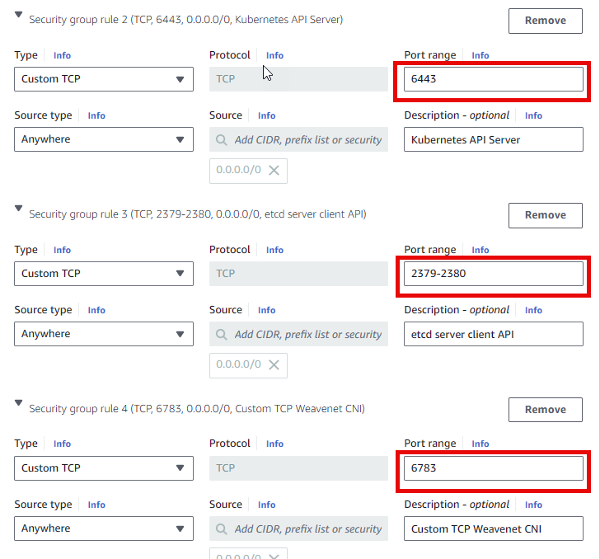

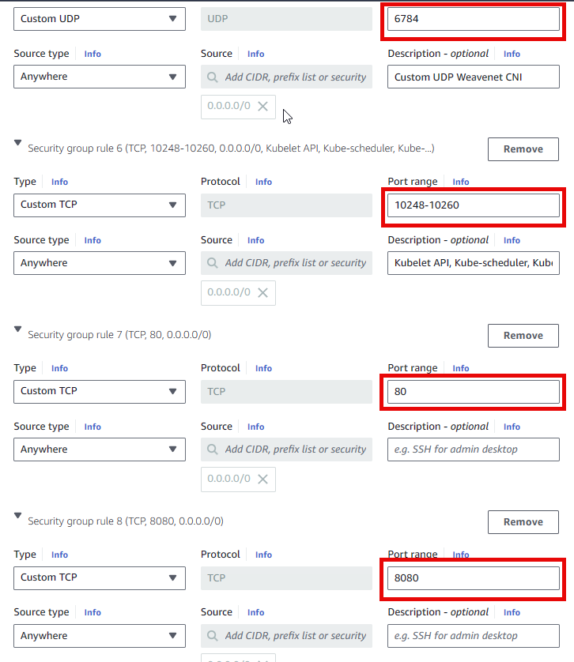

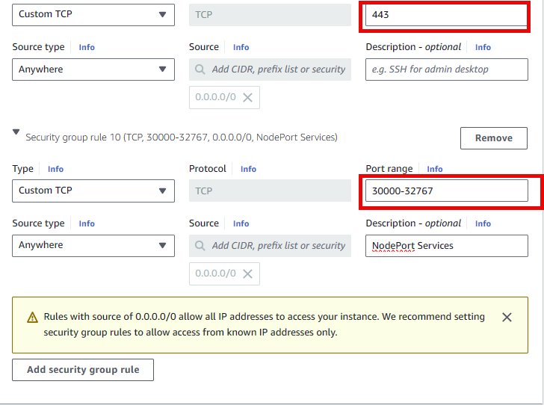

1. Configure storage

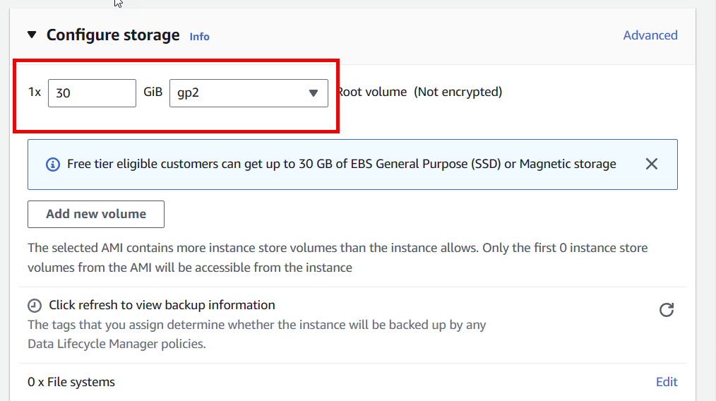

1. Launch instance

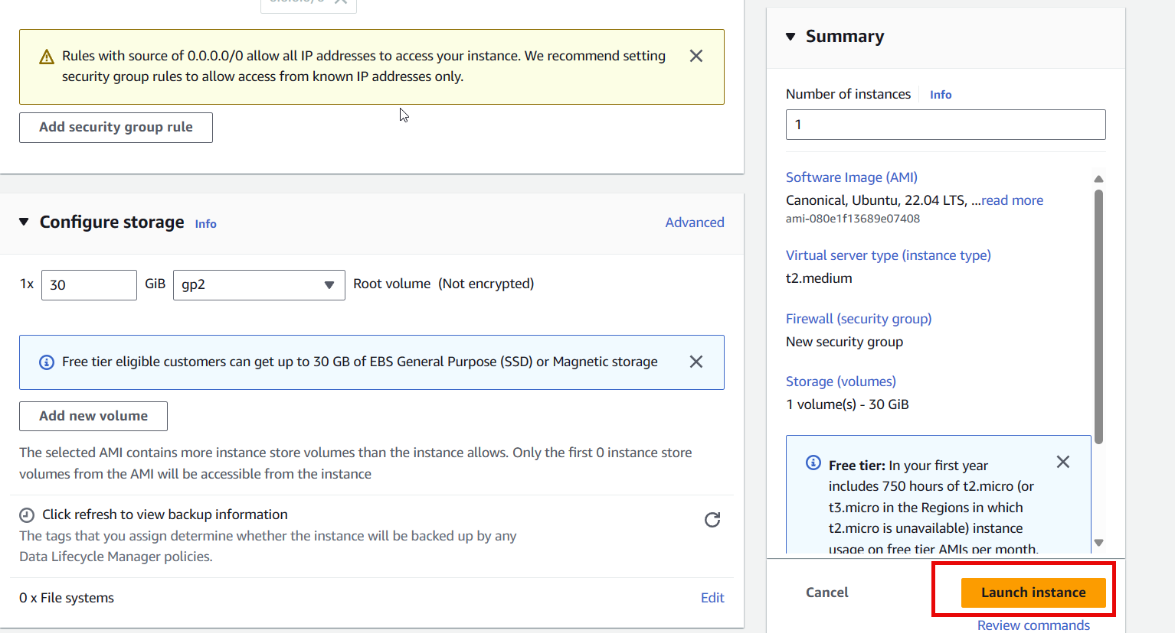

1. Instance is successfully running

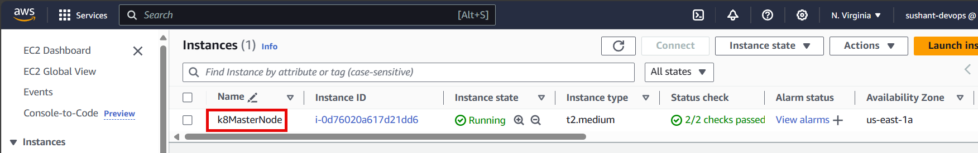

Rename k8MaterNode to K8sMaterNode

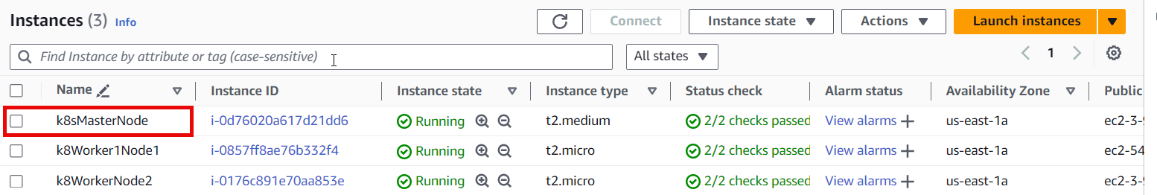

# SETTING UP WORKER NODE ON EC2

1. Search EC2 in services tab.



1. In the Amazon EC2 Dashboard select “Launch Instance” to create and configure your virtual machine.

1. Provide name of instance with 2 instances 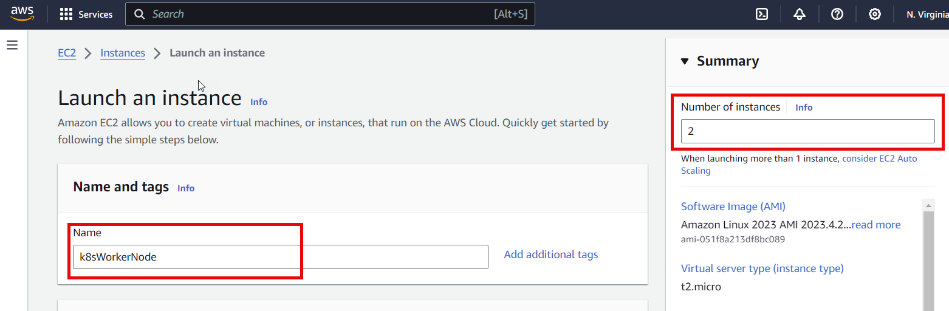
2. Select OS Image



1. Select instance type as t2 medium

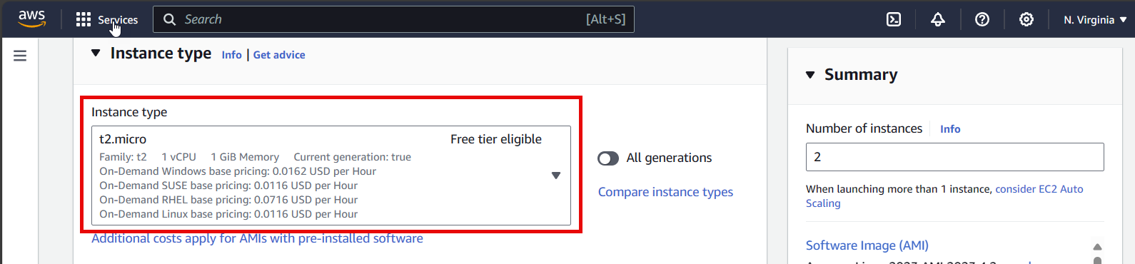

1. Select existing key pair (Proceed with a key pair)

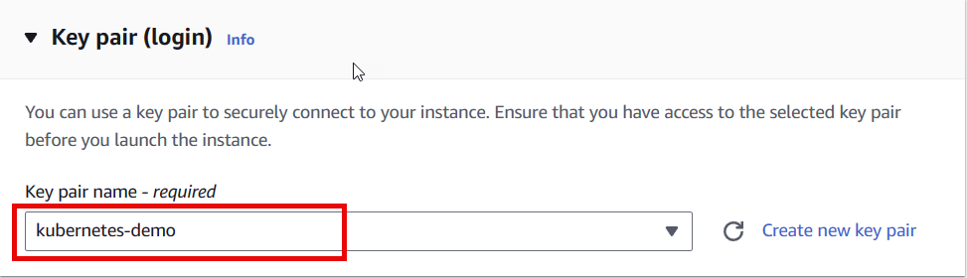

1. Create security group (click on edit)

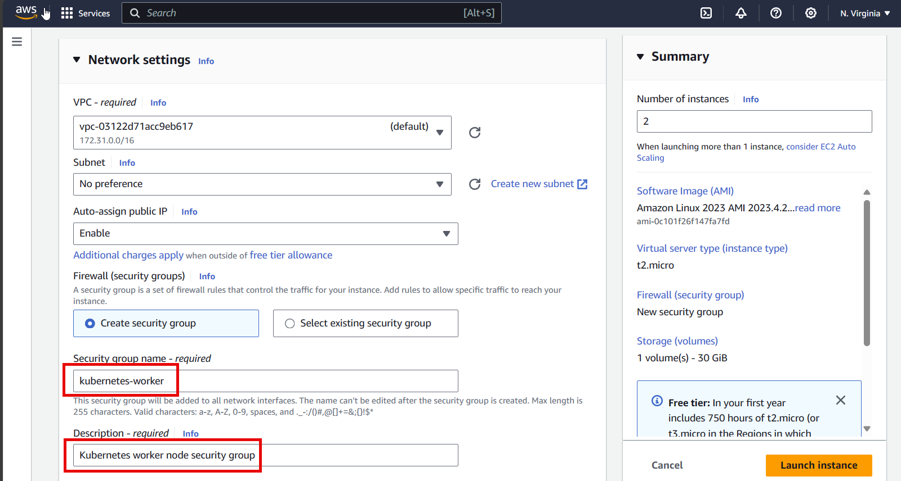

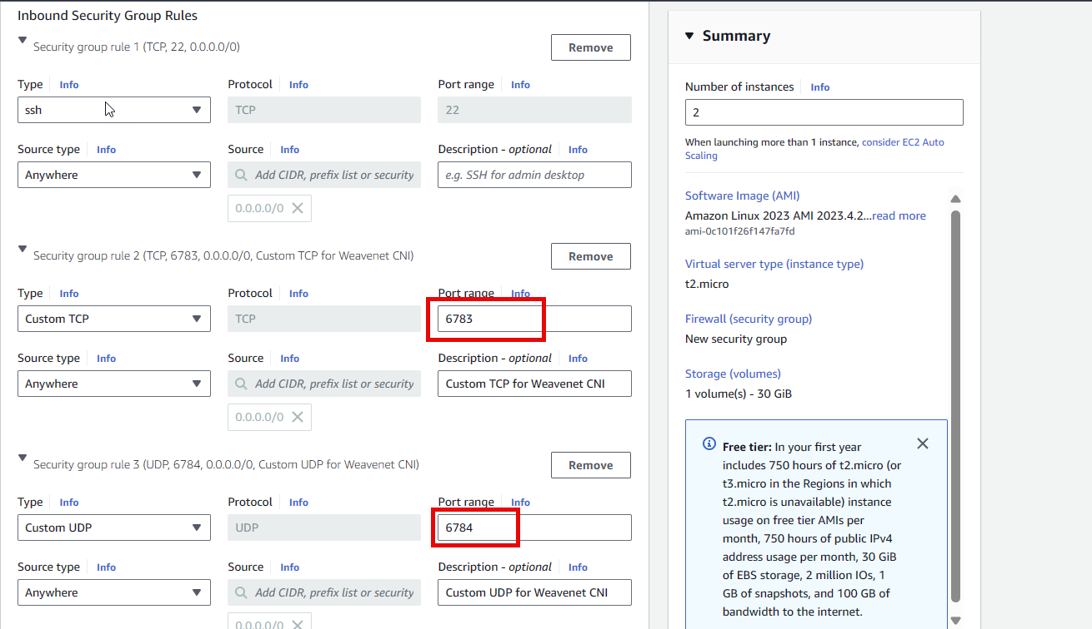

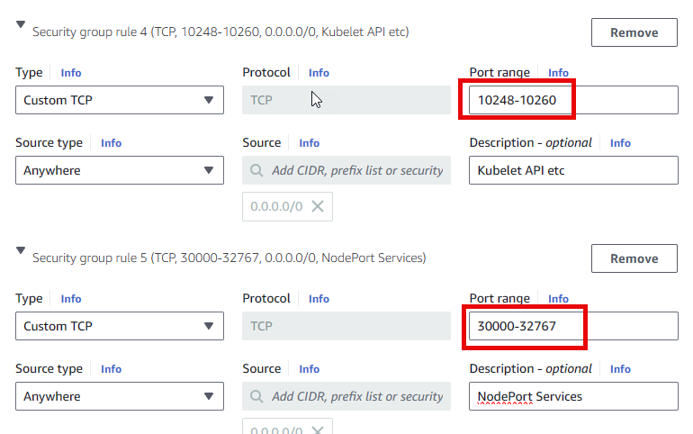

1. Configure storage

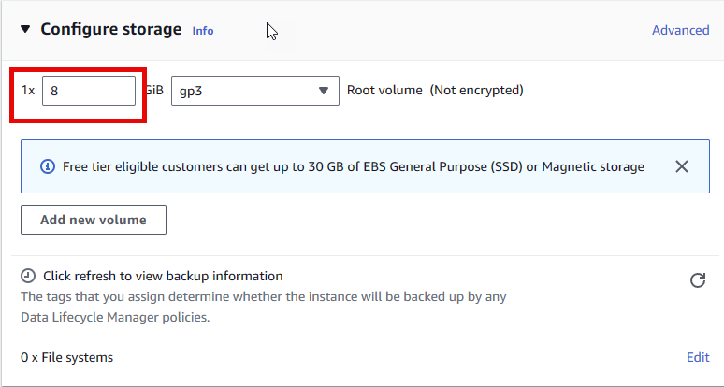

1. Launch instance

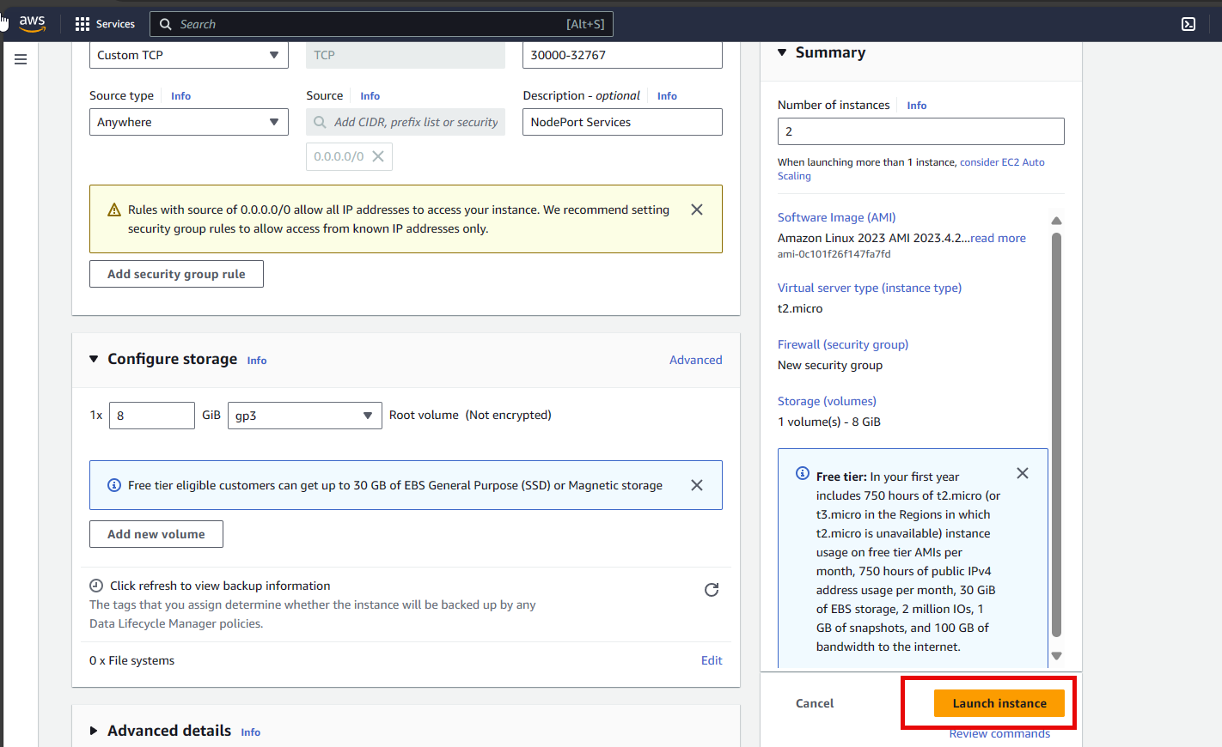

1. Instance is successfully running

Rename k8sWorkerNode to k8sWorkerNode1 and k8sWorkerNode2

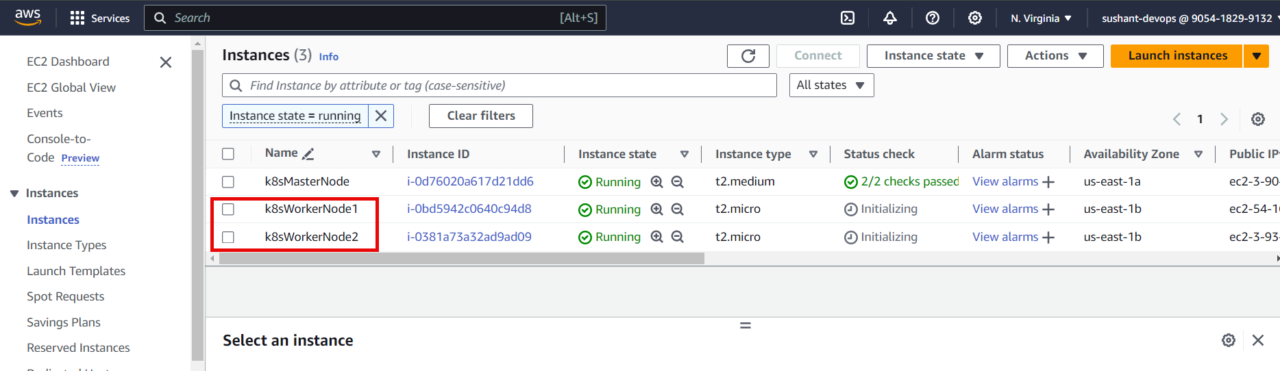

**Steps to connect to EC2 Ununtu Server using MobaXterm:**

## **STEP 1: DOWNLOAD MOBAXTERM**

Download and install MobaXTerm from [official MobaXTerm site](https://www.google.com/url?q=https%3A%2F%2Fmobaxterm.mobatek.net%2Fdownload-home-edition.html&sa=D&sntz=1&usg=AOvVaw2d5a5c-jCNT0w5MuByXmQq) for Windows.

## **STEP 2: HOW TO CONNECT TO AWS EC2 INSTANCE USING MOBAXTERM**

Once Installed open the mobaxterm, Go to **User** **sessions** Menu , click on **NewFolder** as shown below.

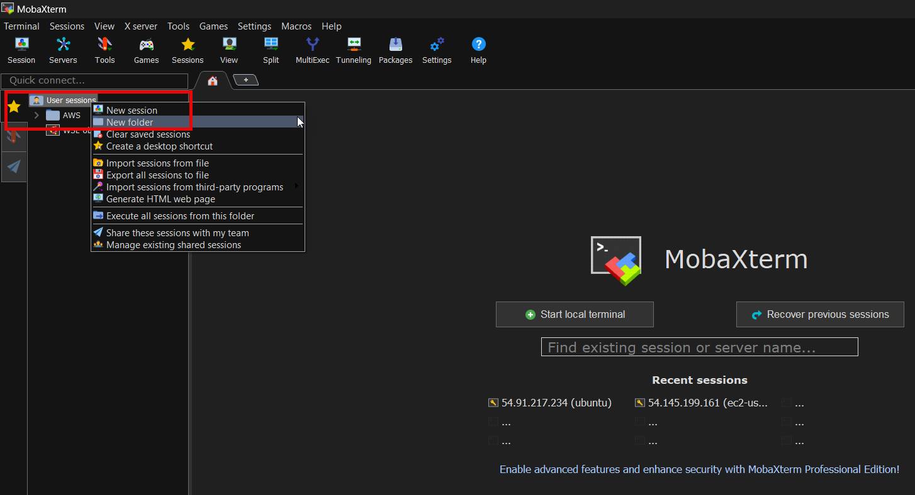

Create a folder named k8sKubeadm and click on OK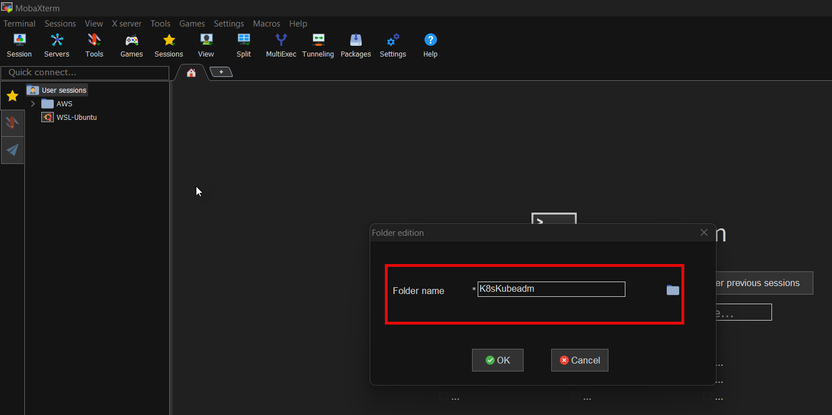

**STEP 3:** Select folderK8sKubeadm and right click on New session, Once you click on **New Session** a new tab **Session settings** will open as shown below. Click on SSH

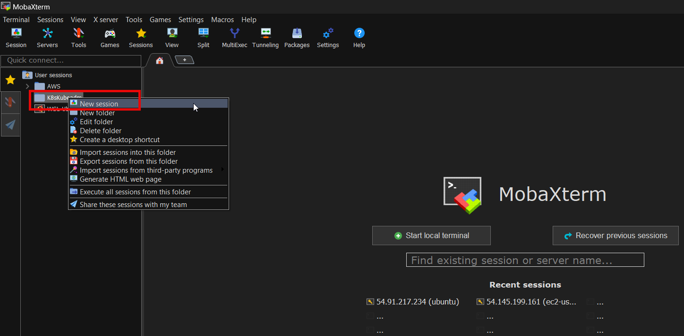

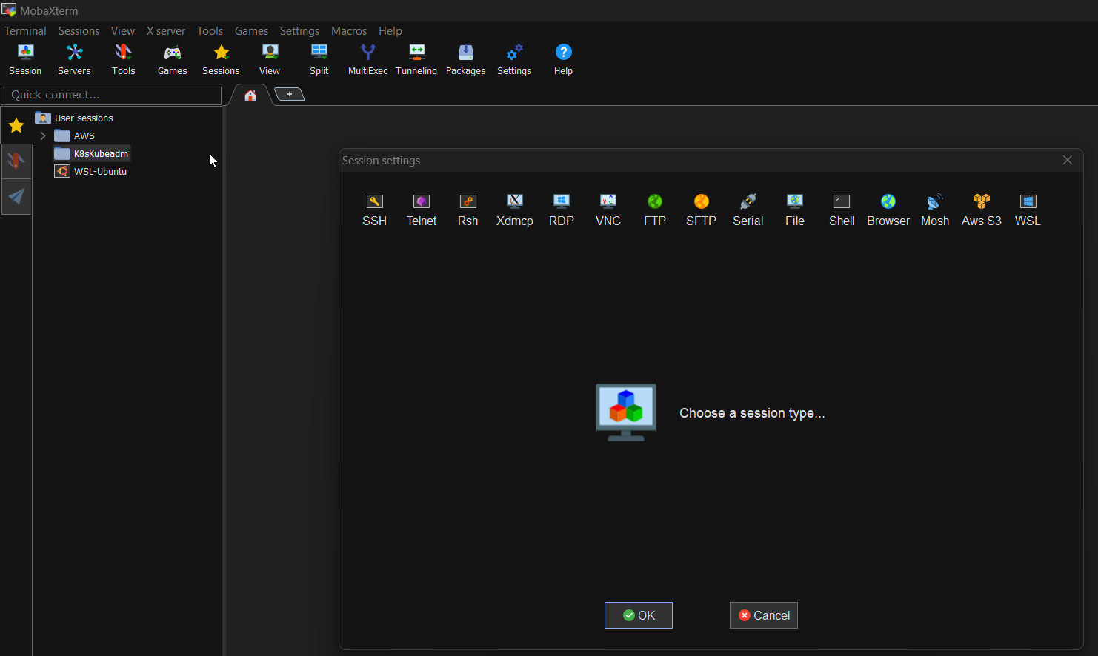

**STEP 4:** Once you click on **SSH**

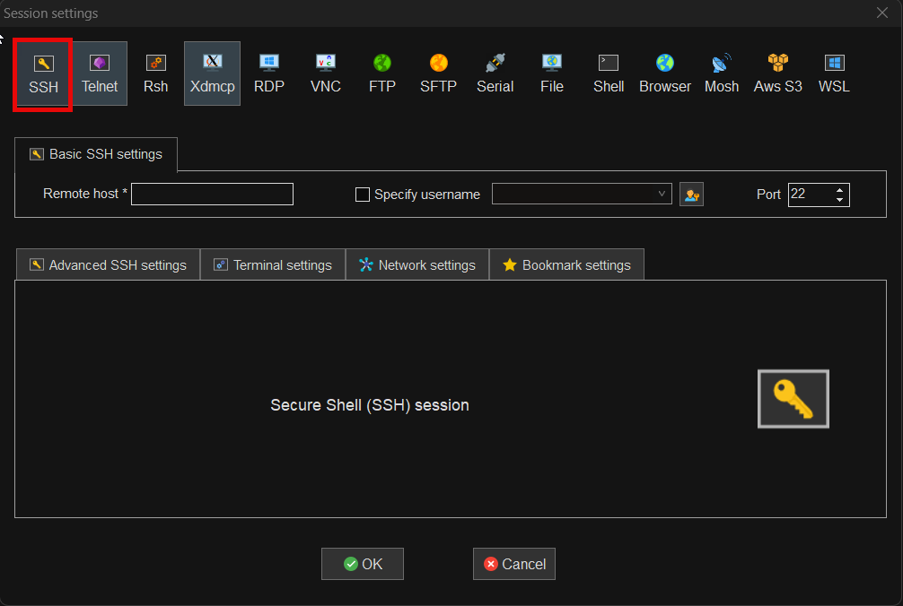

**STEP 5:** Input your AWS EC2 Instance IP, UserName in **Remote Host** and **Specify UserName** field.

Get details from EC2 console:

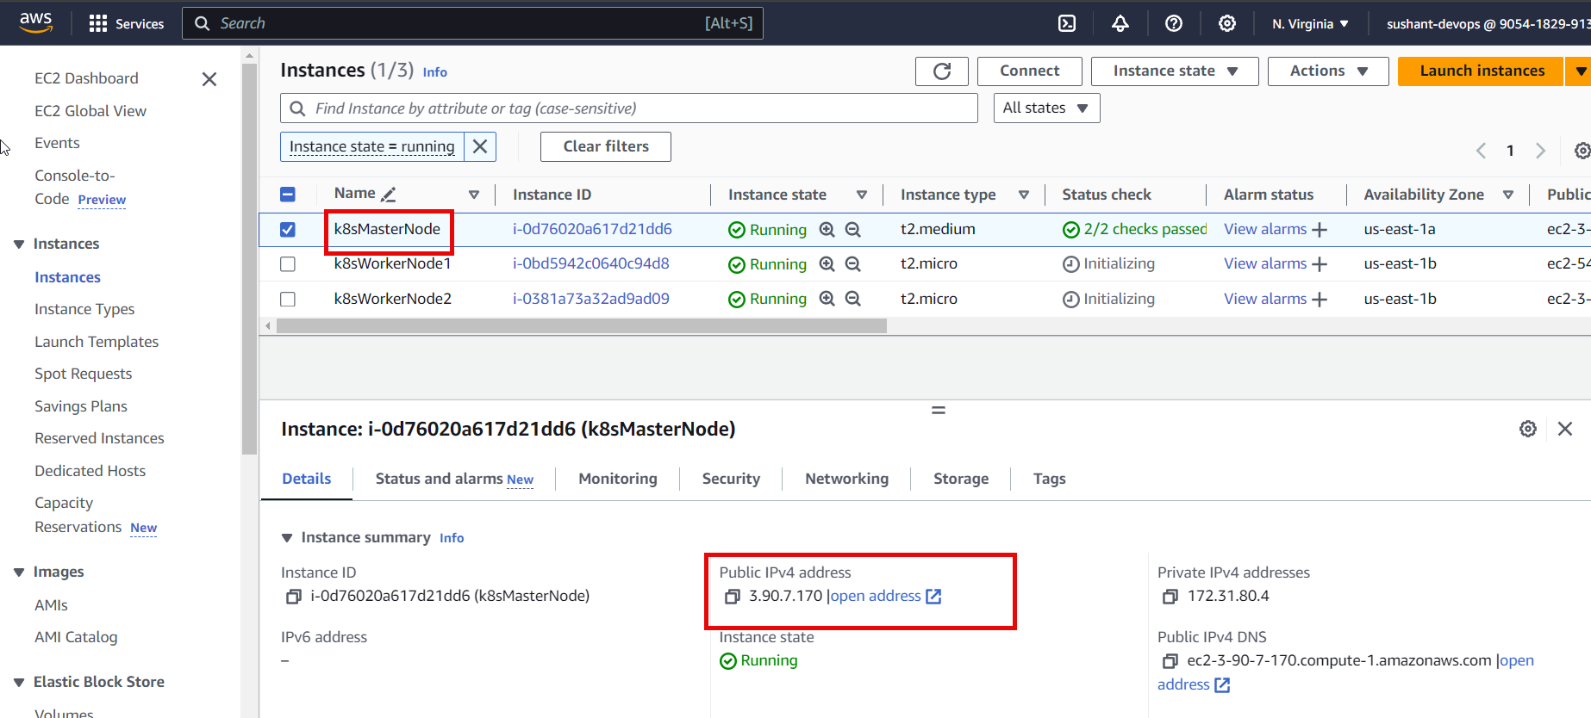

Similarly get details for other worker nodes 1 and worker nodes 2

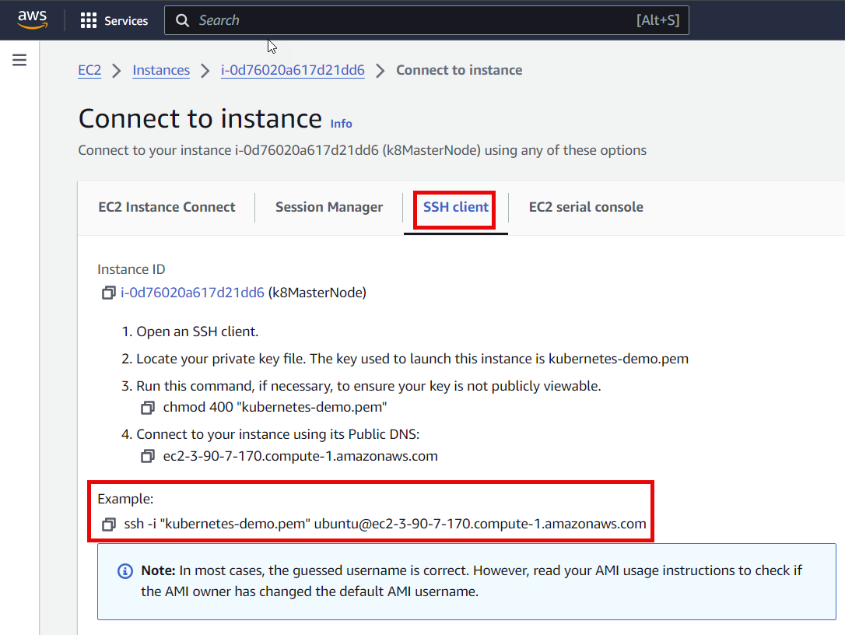

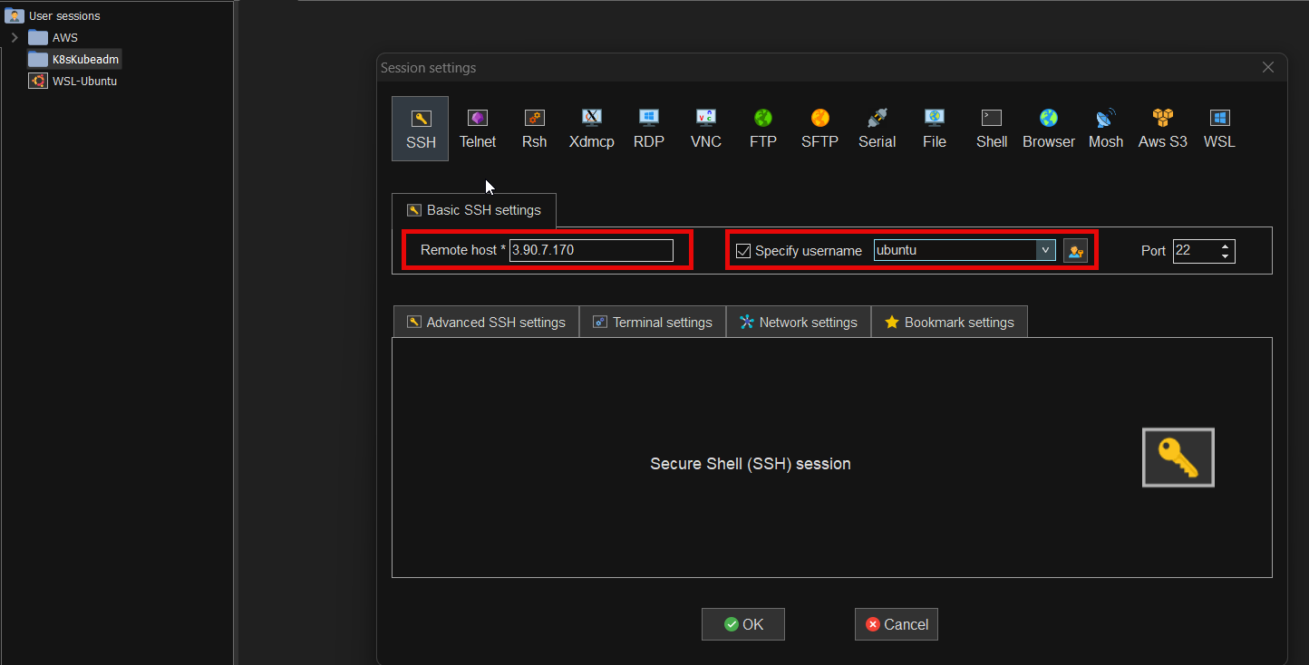

**To get IP address and Username click on Connect to instance as shown in below screenshot:**

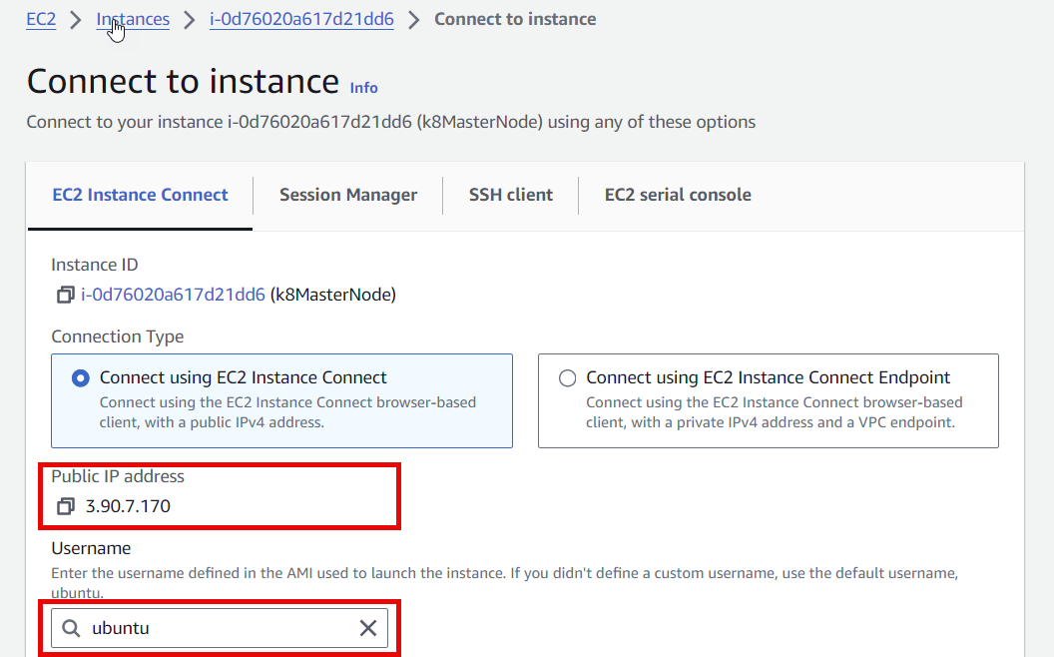

Here I am connecting to Amazon Linux Instance. User name will be **ubuntu**

**NOTE: Steps will be remained same for AmazonLinux, Centos.** If you are connecting other AWS EC2 then type user **ubuntu or centos or admin...** into the field **Specify username**

**STEP 6:** Click on **Advanced SSH Settings** tab and give the path of your instance .pem file in field **use Private key** as shown below

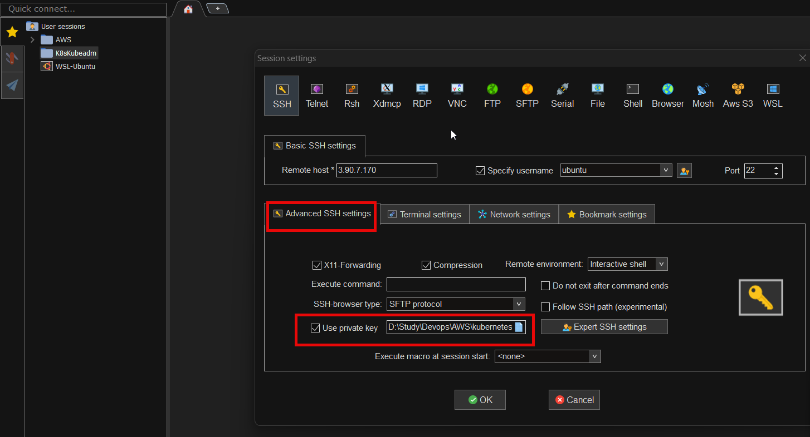

**STEP 7:** Click on **OK** button to connect AWS EC2 instance using mobaxterm

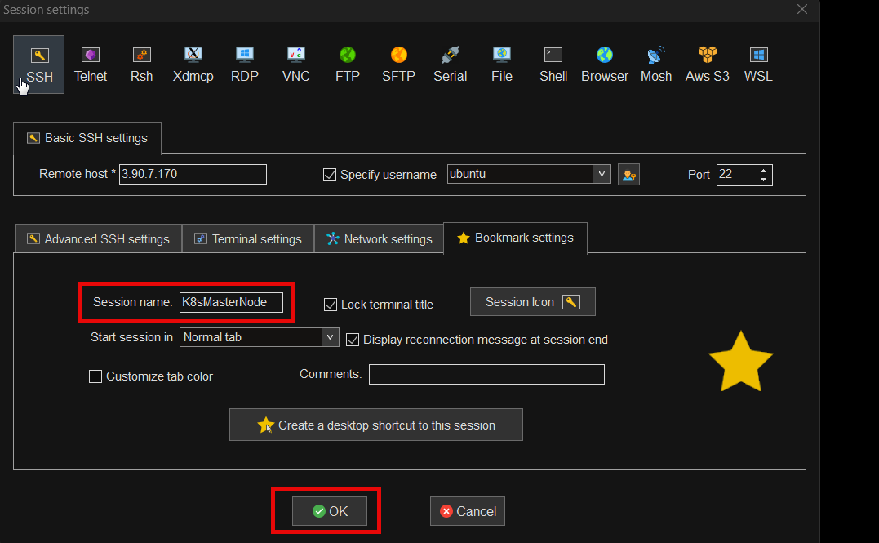

**The steps to connect K8WorkerNode1 and K8WorkerNode2 remains same.**

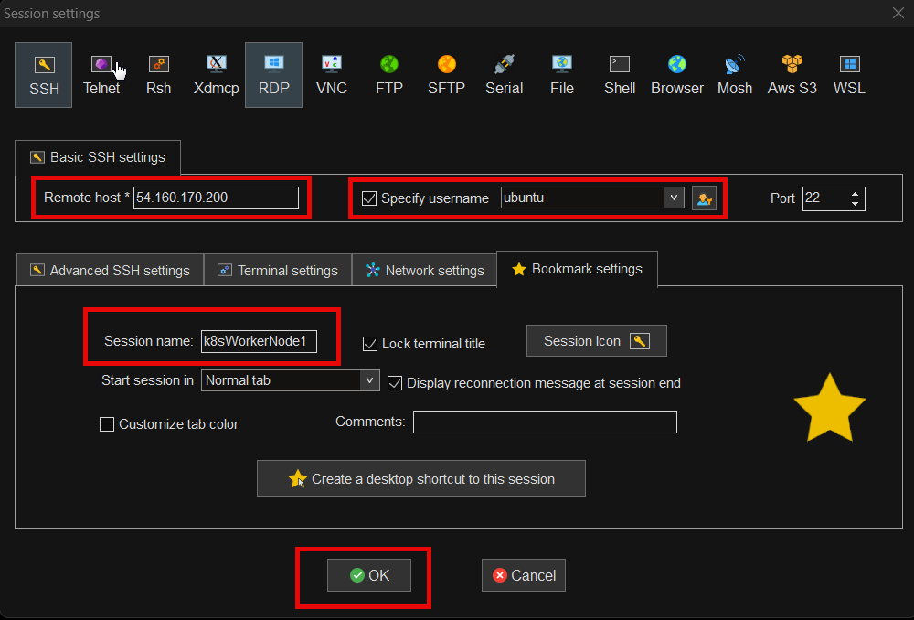

K8sWorkerNode2

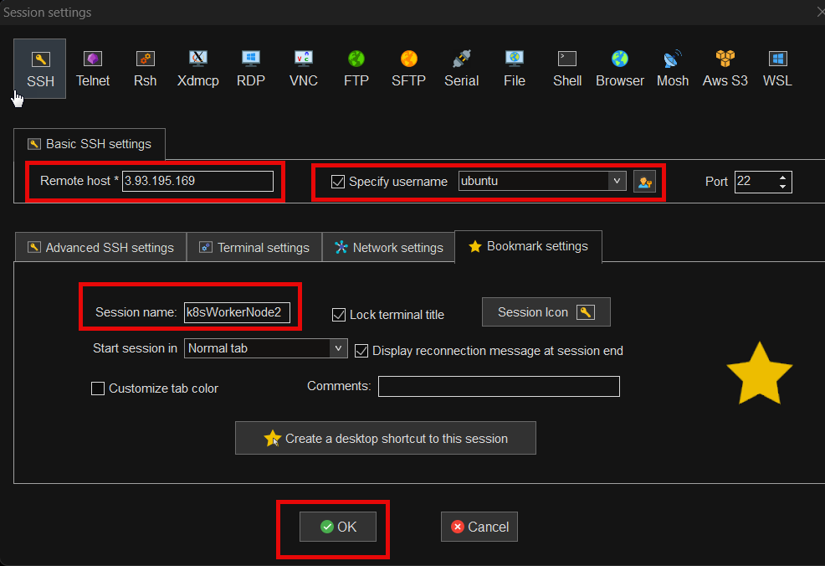

**STEP 8:** Once connected, you will see like below AWS Instance SSH terminal

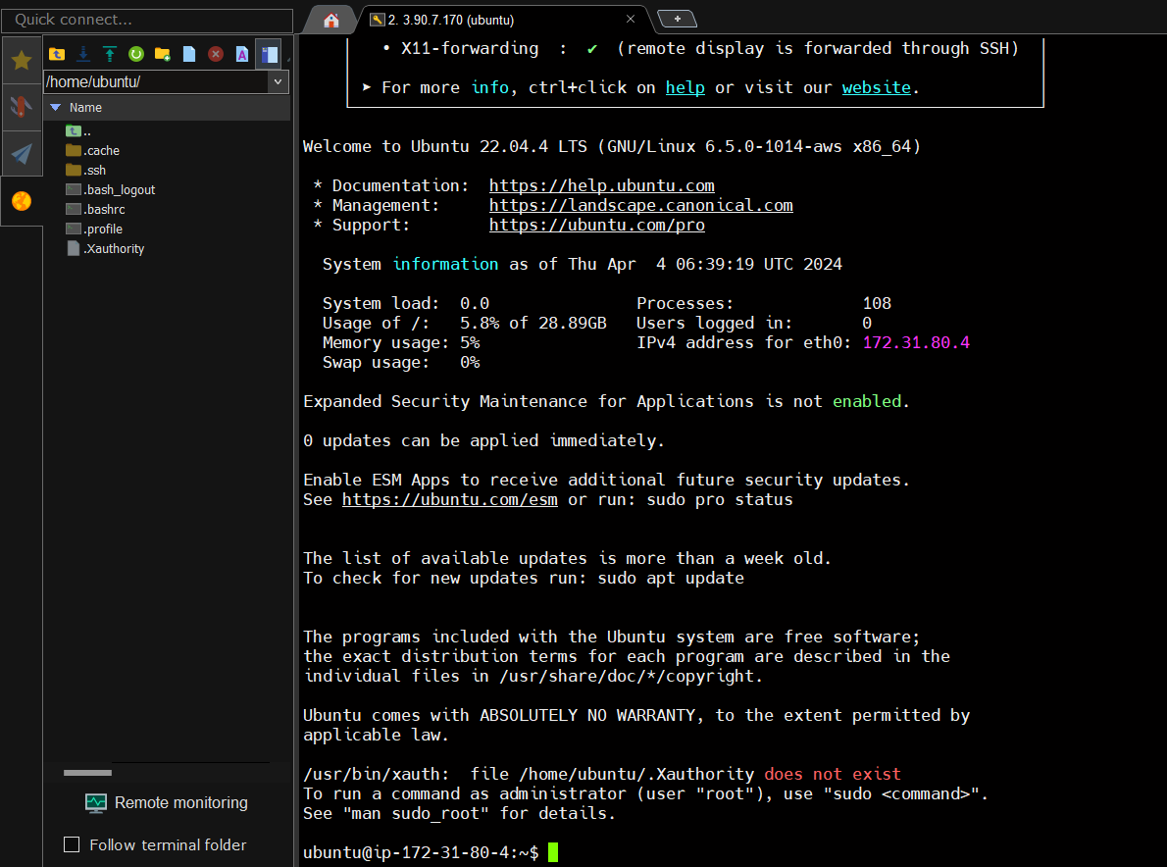

**Step2:**

**Setting hostname for both master and worker node**

**hostname**

|  |
| --- |
| **hostname**  **hostnamectl set-hostname master**  **hostname** |

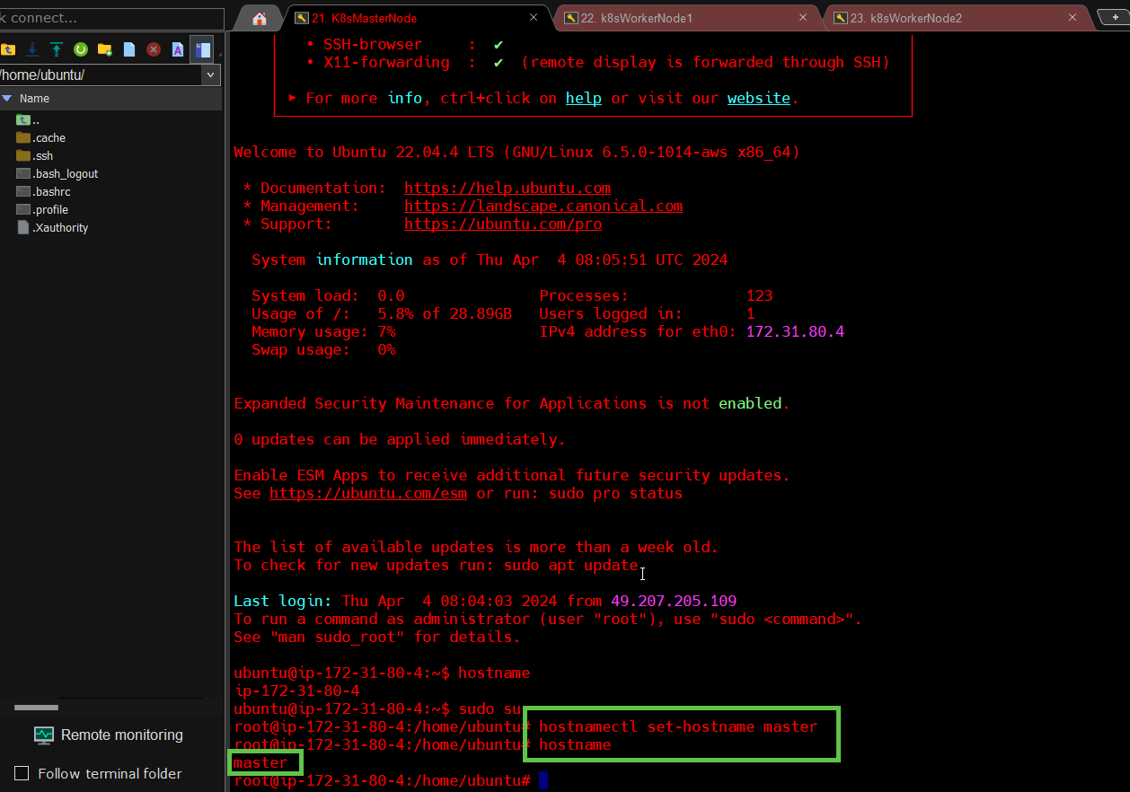

**workerNode1**

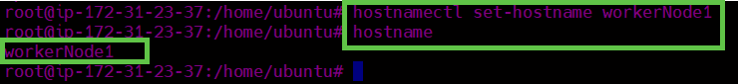

**workerNode2**

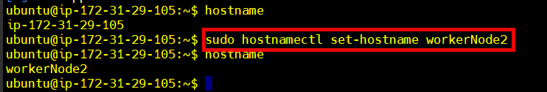

**Step3**:

Disable swap on Both " **Master** " & " **Worker** Node.

Click on Multiexec and execute below commands:

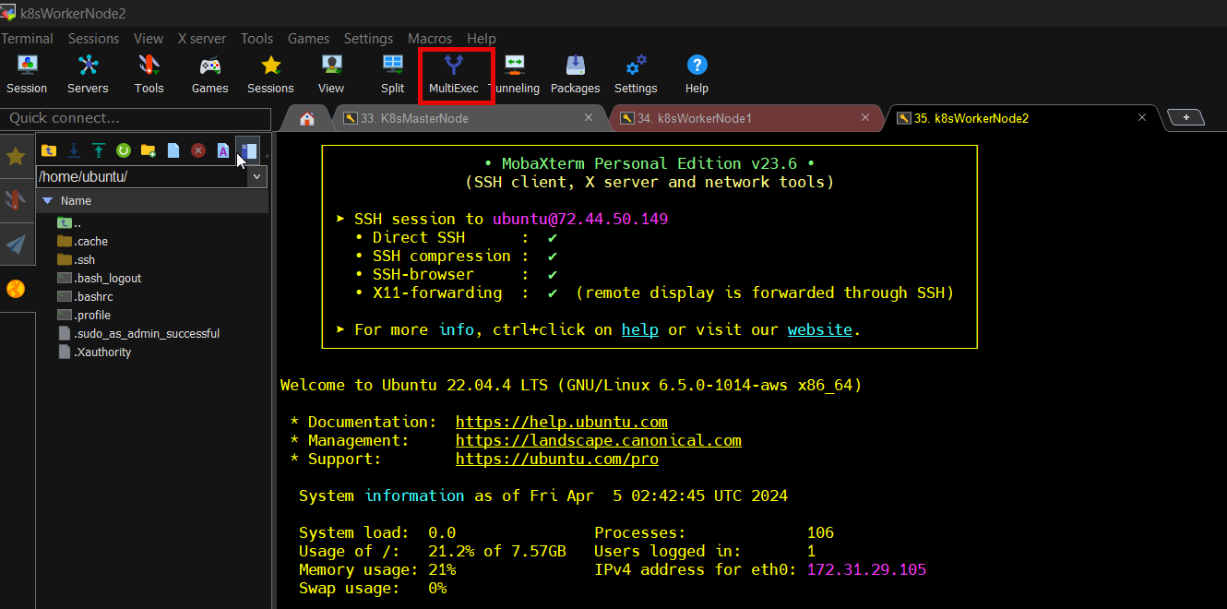

|  |
| --- |
| **sudo swapoff -a**  **sudo sed -i '/ swap / s/^\(.*\)$/#\1/g' /etc/fstab** |

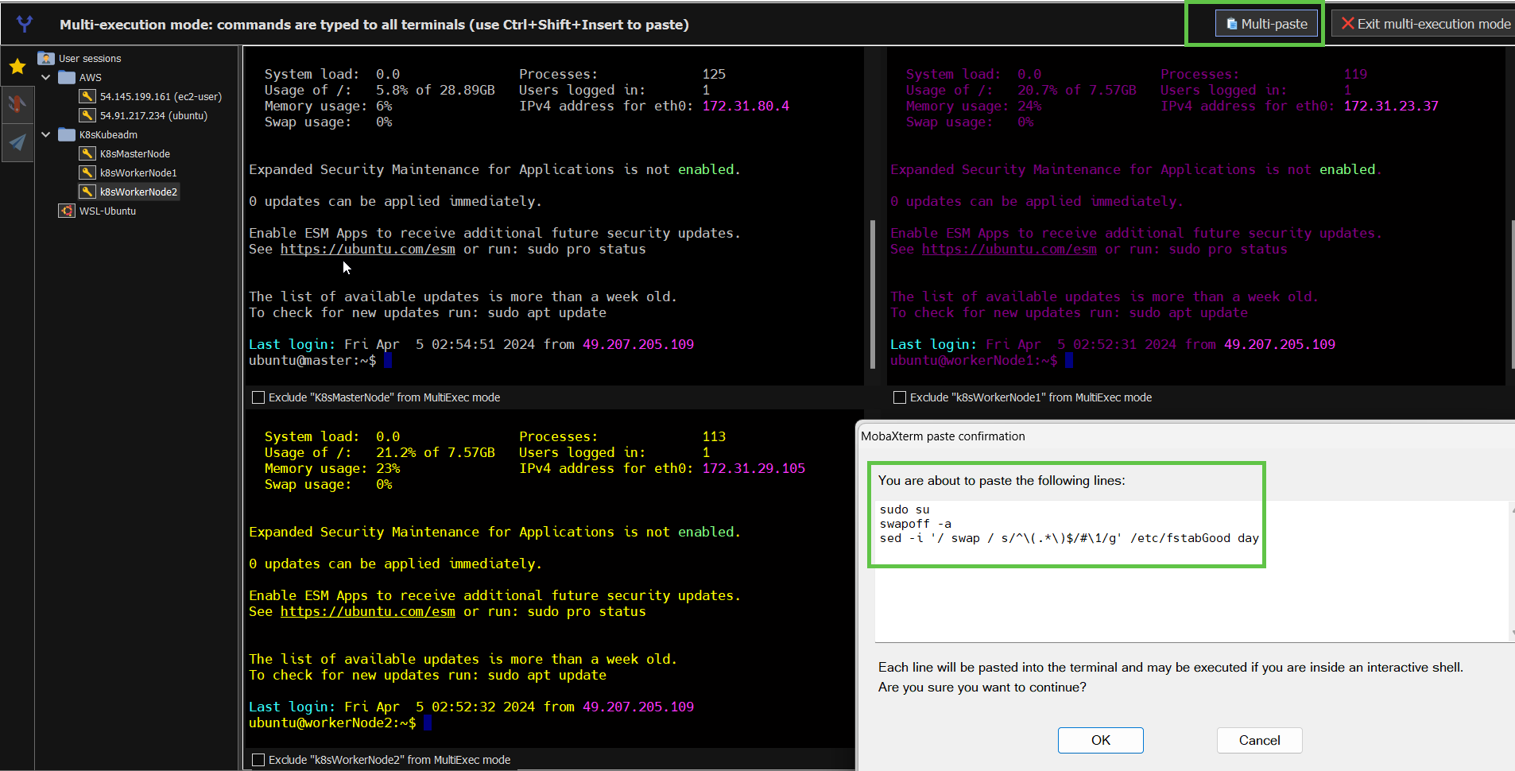

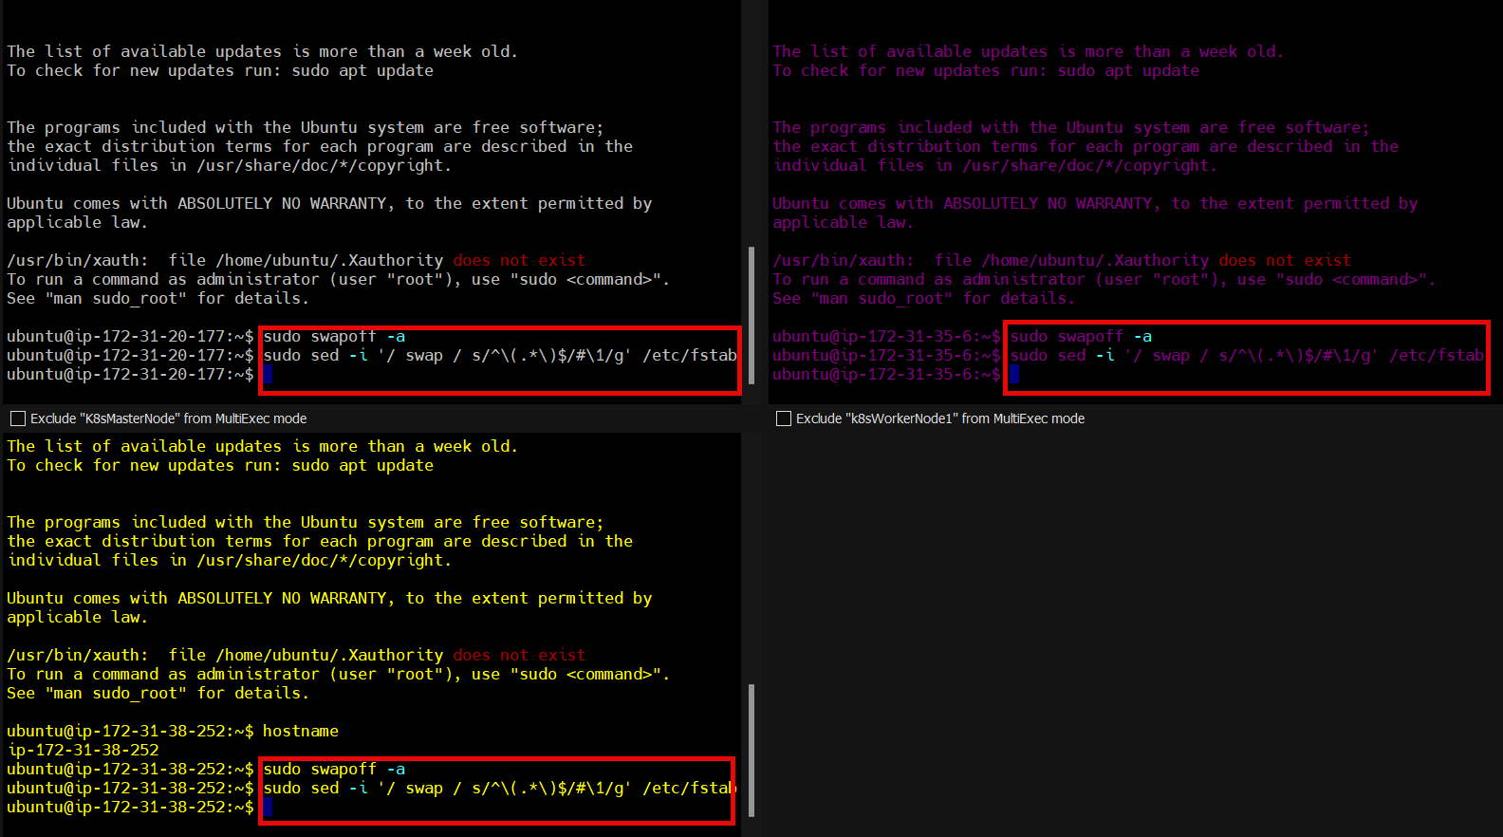

Note: Run on all nodes of the cluster as root user

**Step4**:

To install containerd (run as sudo user)

|  |
| --- |
| **wget https://github.com/containerd/containerd/releases/download/v1.7.13/containerd-1.7.13-linux-amd64.tar.gz**  **tar Cxzvf /usr/local containerd-1.7.13-linux-amd64.tar.gz**  **wget https://raw.githubusercontent.com/containerd/containerd/main/containerd.service**  **mkdir -p /usr/local/lib/systemd/system**  **mv containerd.service /usr/local/lib/systemd/system/containerd.service**  **systemctl daemon-reload**  **systemctl enable --now containerd** |

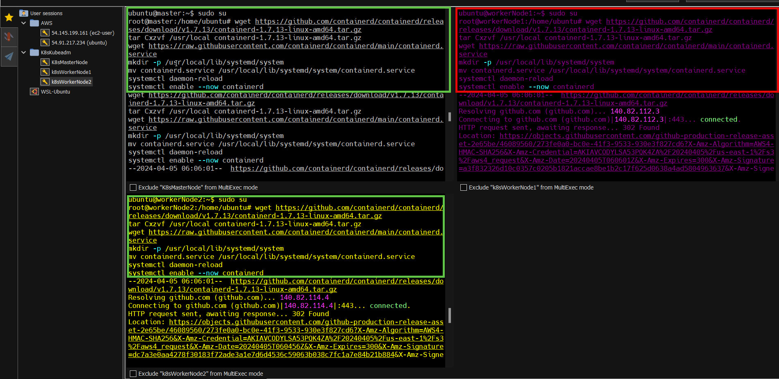

**systemctl status containerd**

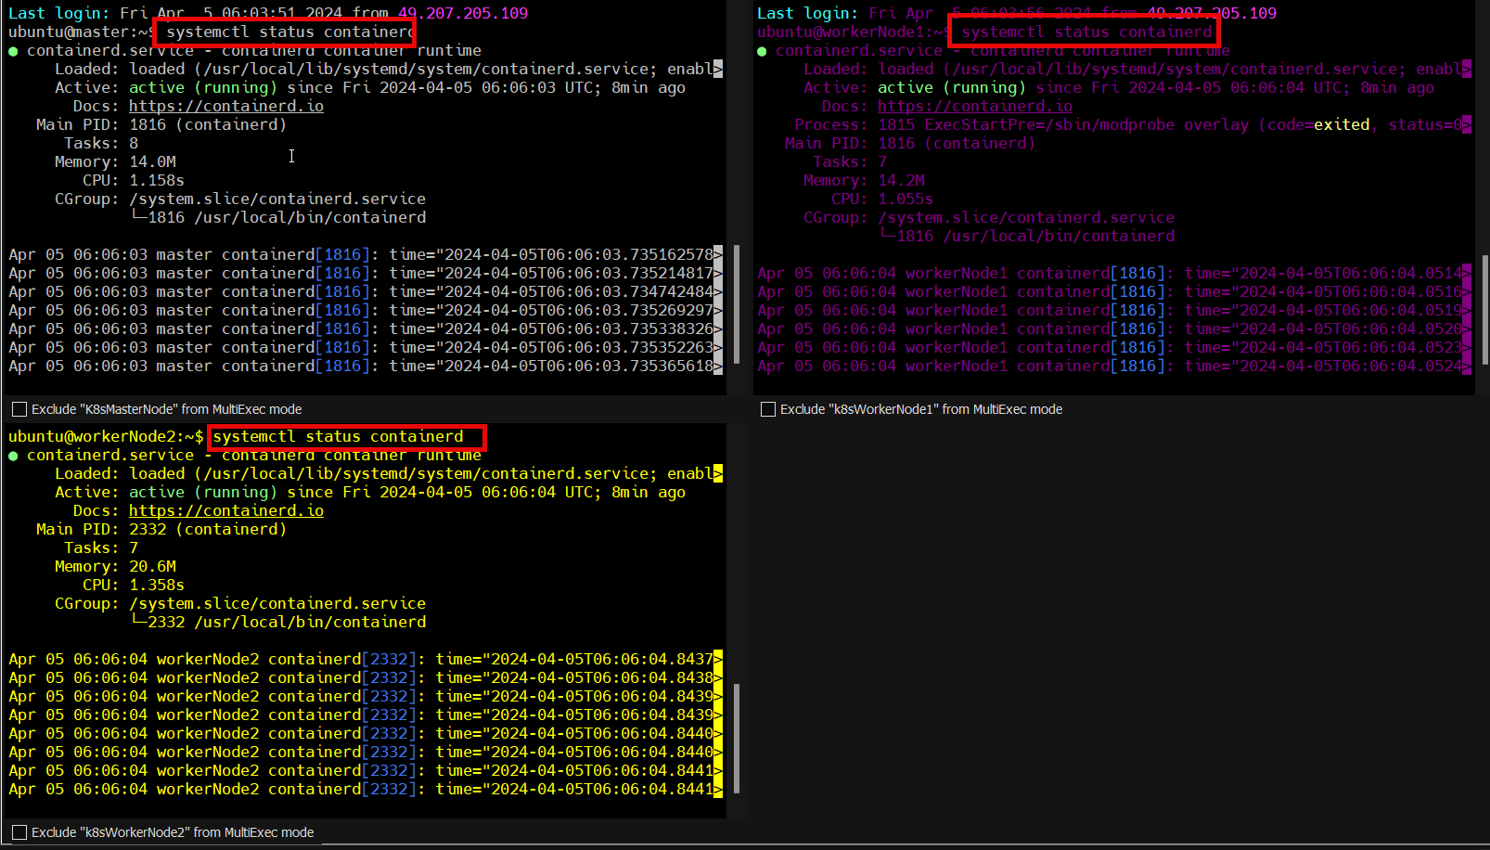

**If we type docker we get error as docker is not installed**

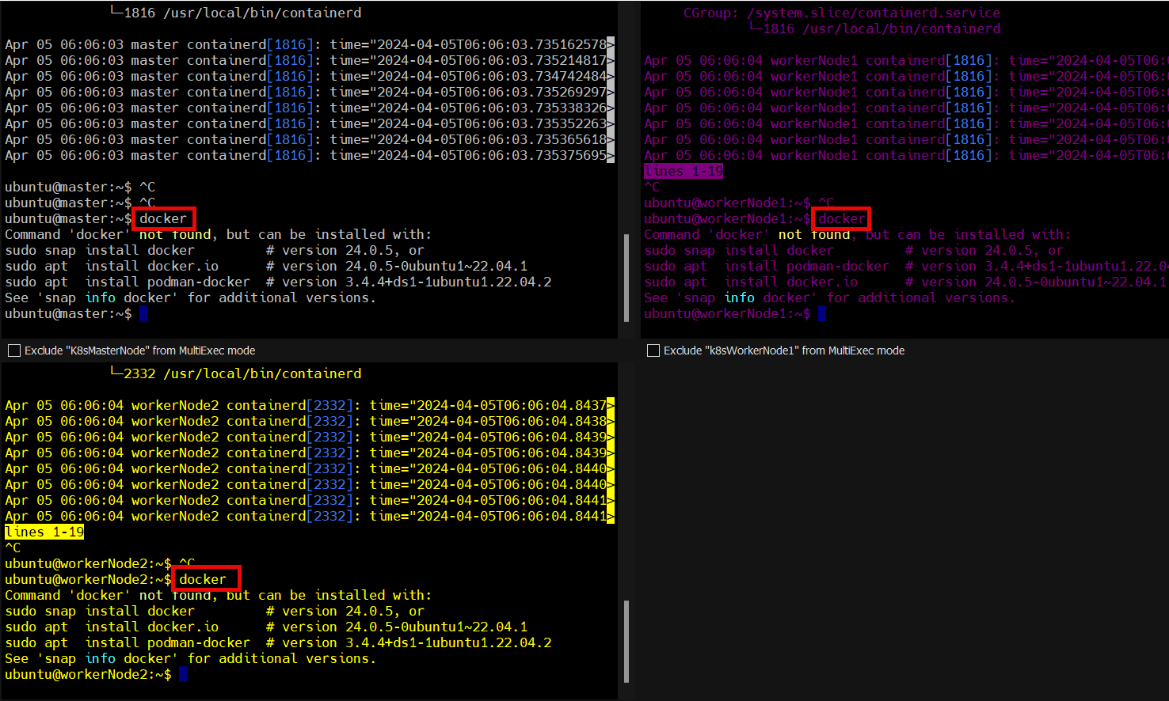

**Step5**:

Install Runc (Low level container tuntime)

|  |
| --- |
| **wget https://github.com/opencontainers/runc/releases/download/v1.1.12/runc.amd64**  **install -m 755 runc.amd64 /usr/local/sbin/runc** |

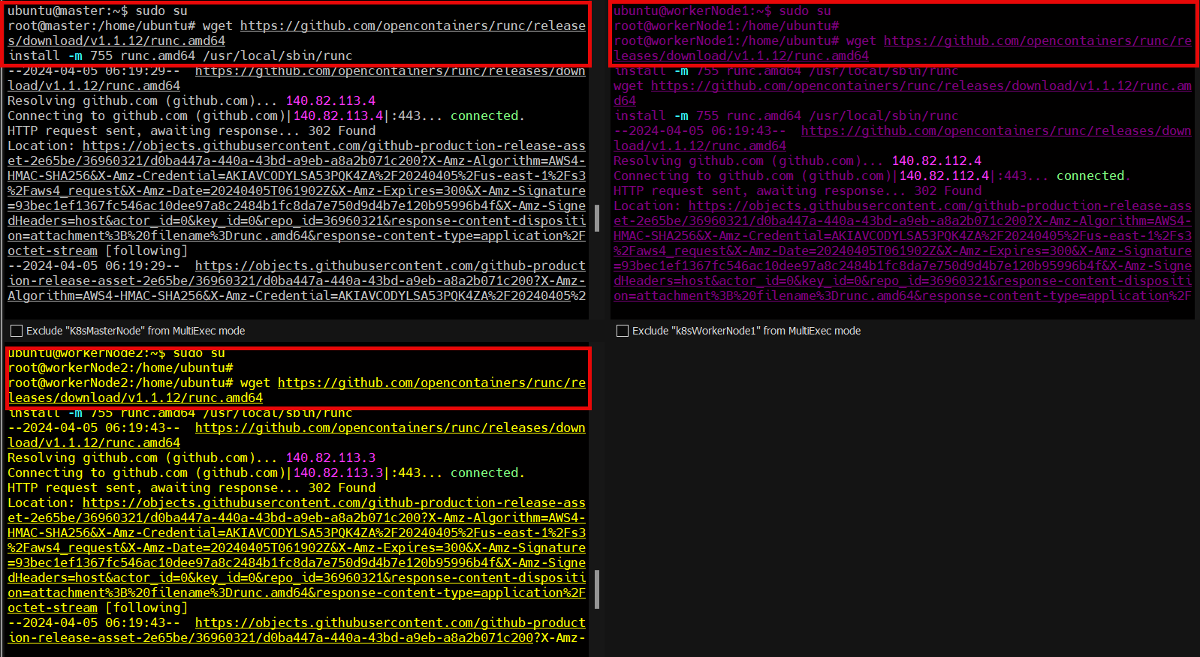

**Step6**:

Install CNI

|  |
| --- |
| **wget https://github.com/containernetworking/plugins/releases/download/v1.4.0/cni-plugins-linux-amd64-v1.4.0.tgz**  **mkdir -p /opt/cni/bin**  **tar Cxzvf /opt/cni/bin cni-plugins-linux-amd64-v1.4.0.tgz** |

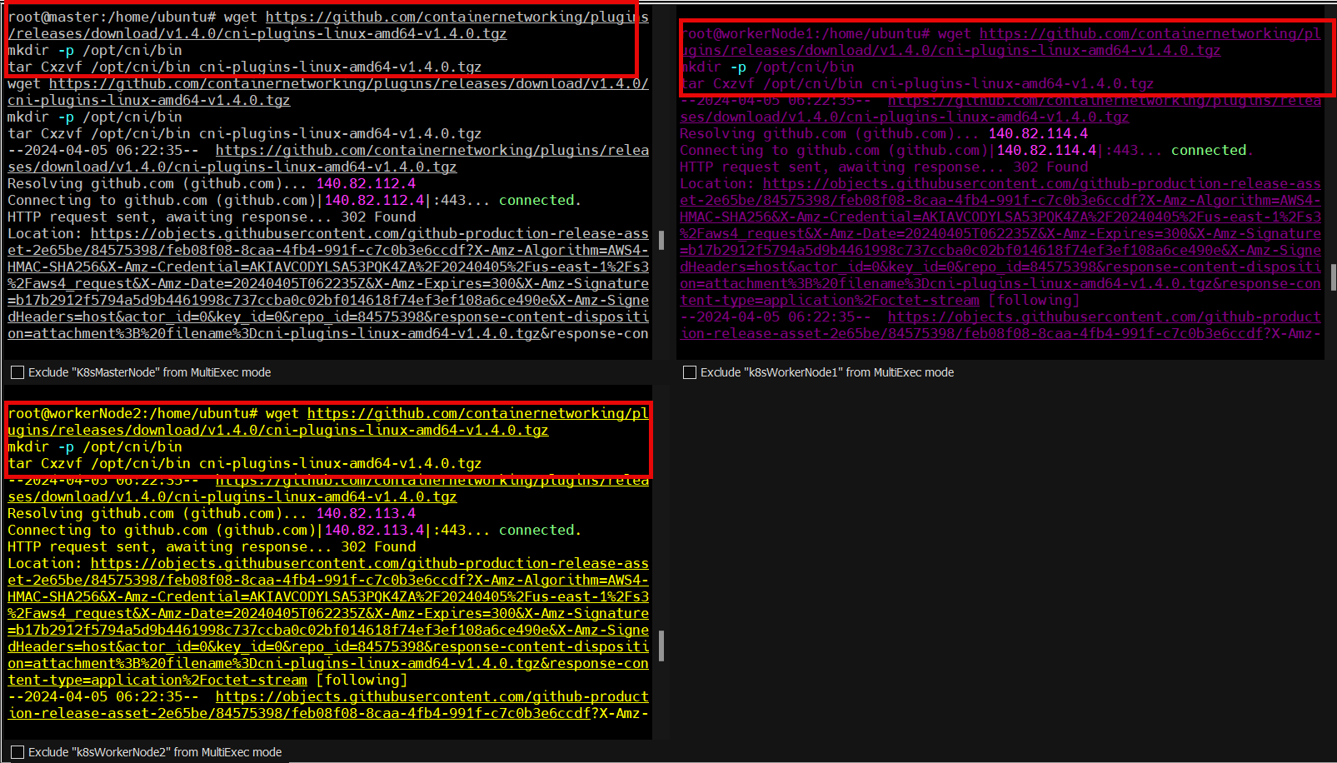

**Step7**. Install critctl

|  |
| --- |
| **VERSION="v1.29.0" # check latest version in /releases page**  **wget https://github.com/kubernetes-sigs/cri-tools/releases/download/$VERSION/crictl-$VERSION-linux-amd64.tar.gz**  **sudo tar zxvf crictl-$VERSION-linux-amd64.tar.gz -C /usr/local/bin**  **rm -f crictl-$VERSION-linux-amd64.tar.gz** |

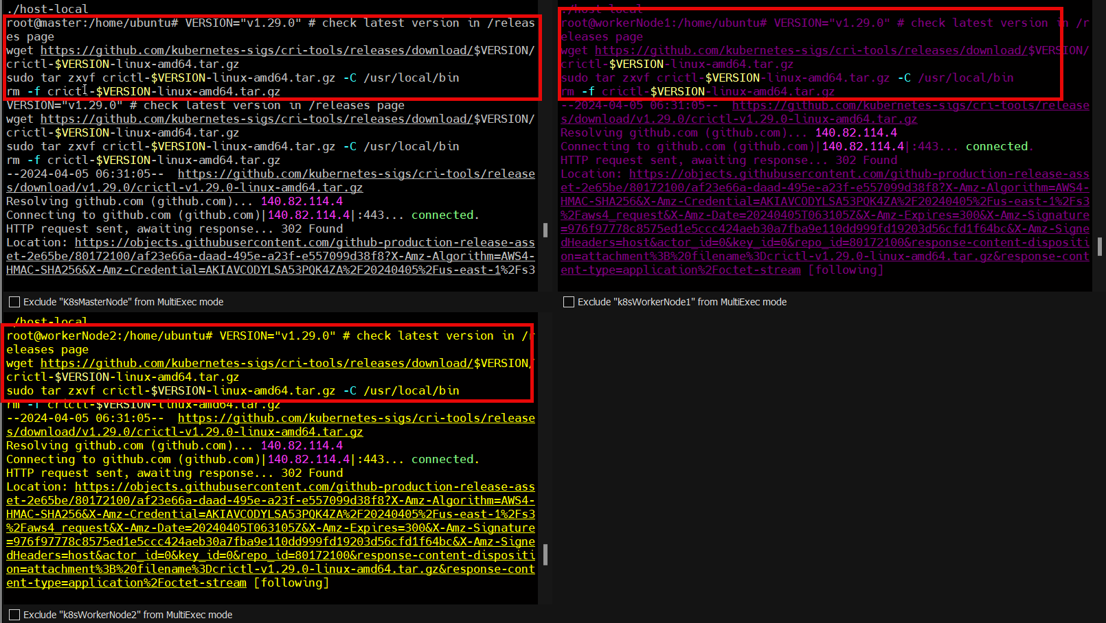

Crictl ps

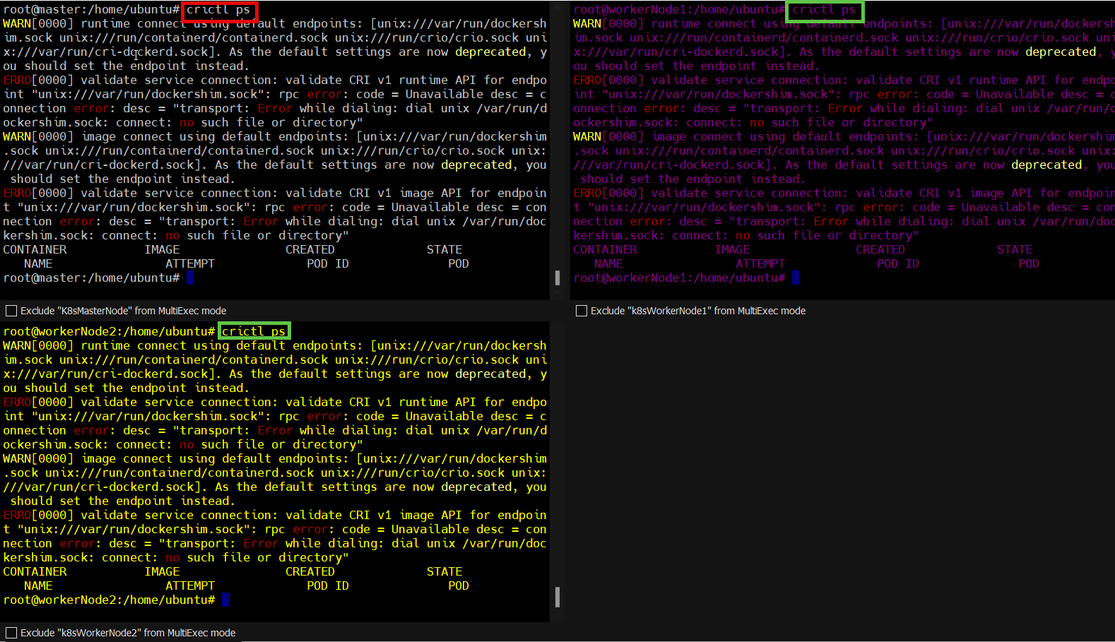

Configuring crictl to talk to containerd

|  |
| --- |
| **cat <<EOF | sudo tee /etc/crictl.yaml**  **runtime-endpoint: unix:///run/containerd/containerd.sock**  **image-endpoint: unix:///run/containerd/containerd.sock**  **timeout: 2**  **debug: false**  **pull-image-on-create: false**  **EOF** |

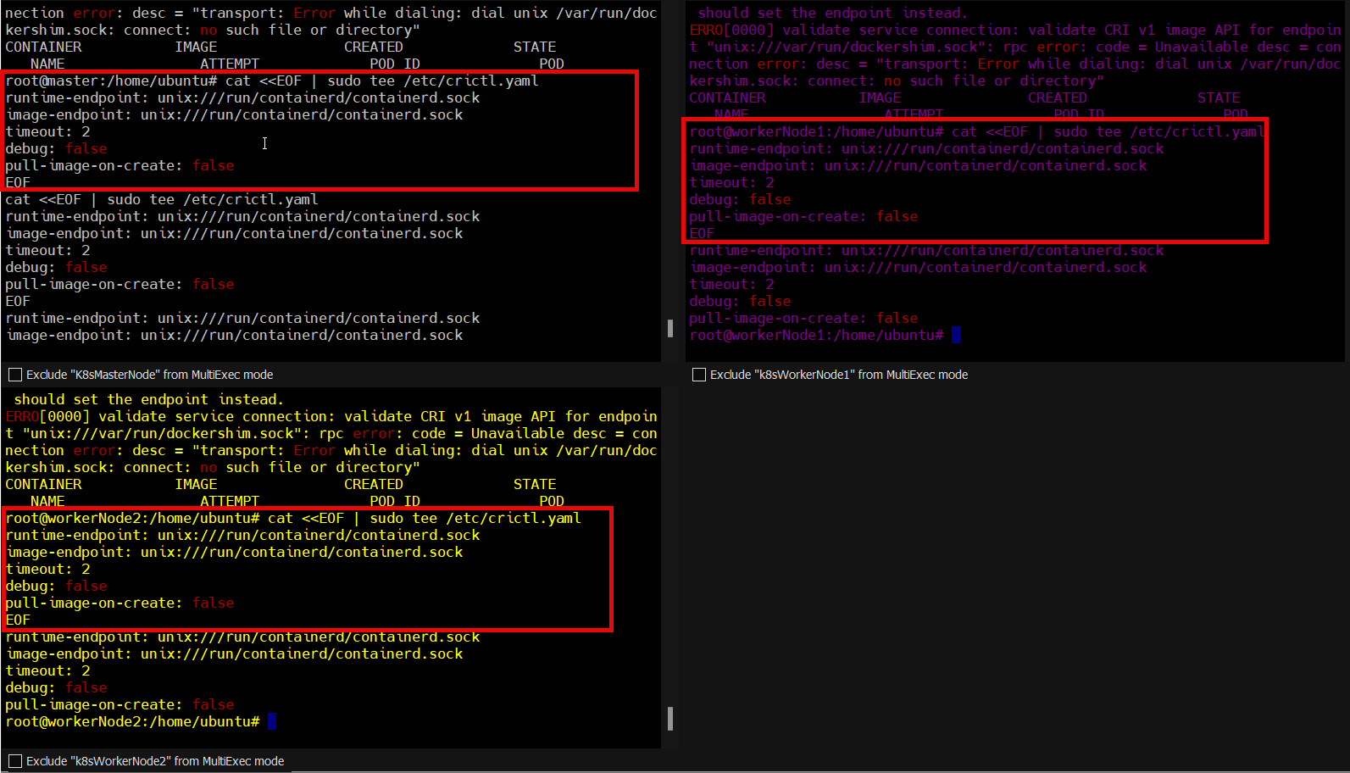

Crictl ps

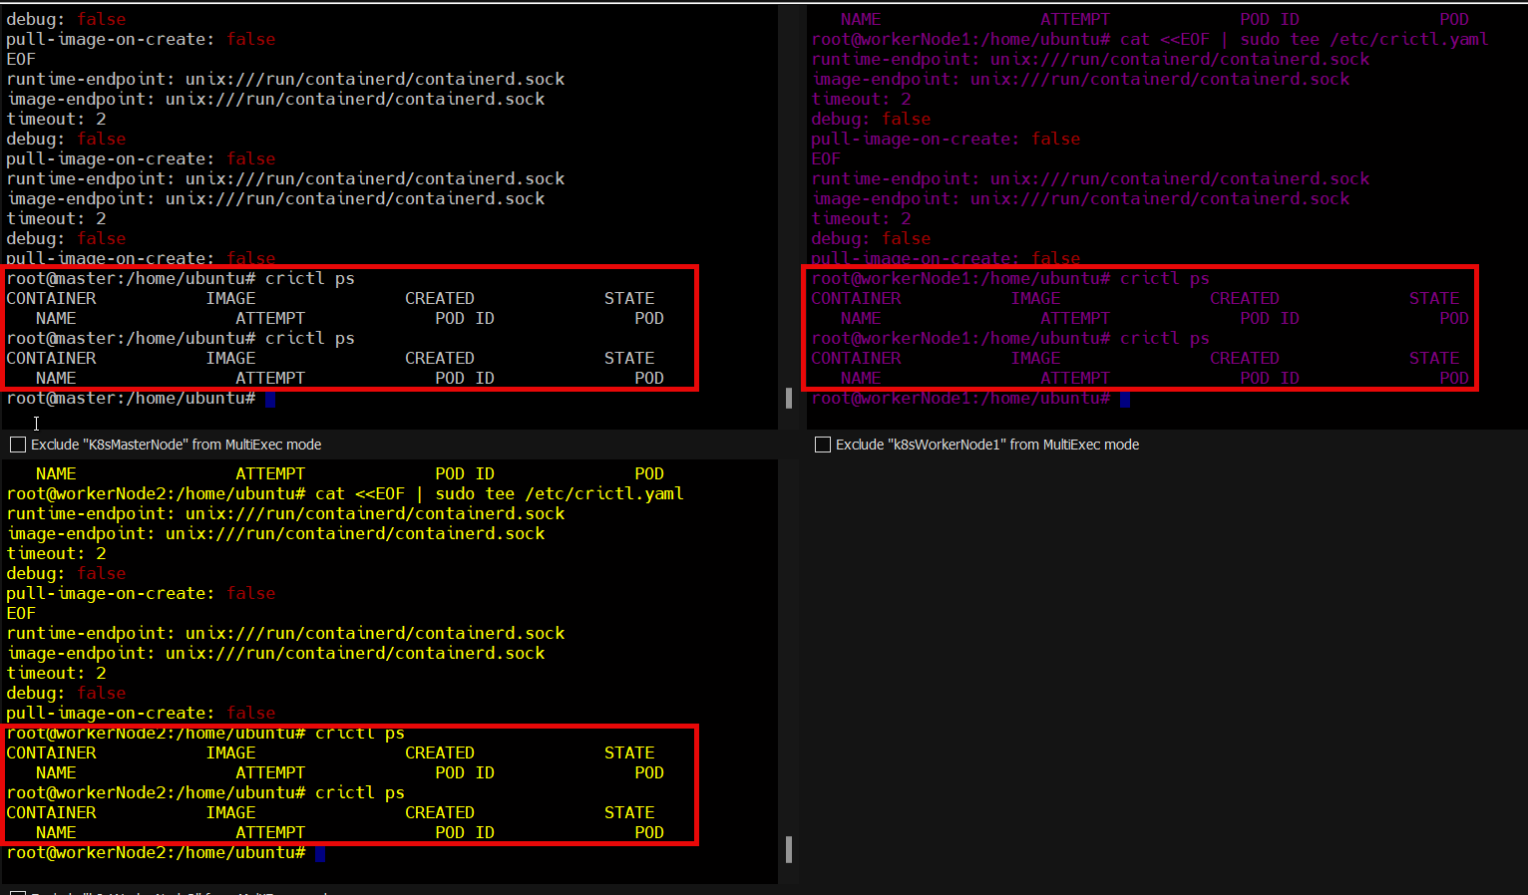

**Step8**. Forwarding IPv4 and letting iptables see bridged traffic

|  |
| --- |
| **cat <<EOF | sudo tee /etc/modules-load.d/k8s.conf**  **overlay**  **br_netfilter**  **EOF**  **sudo modprobe overlay**  **sudo modprobe br_netfilter**  **cat <<EOF | sudo tee /etc/sysctl.d/k8s.conf**  **net.bridge.bridge-nf-call-iptables = 1**  **net.bridge.bridge-nf-call-ip6tables = 1**  **net.ipv4.ip_forward = 1**  **EOF**  **sudo sysctl --system**  **sysctl net.bridge.bridge-nf-call-iptables net.bridge.bridge-nf-call-ip6tables net.ipv4.ip_forward**  **modprobe br_netfilter**  **sysctl -p /etc/sysctl.conf** |

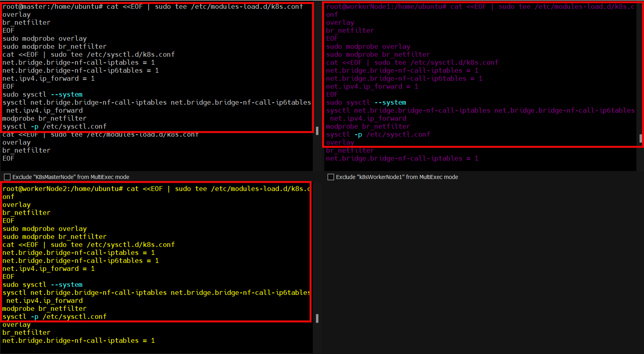

**Step9**: Install kubectl, kubelet and kubeadm

|  |
| --- |
| **sudo apt-get update -y**  **sudo apt-get install -y software-properties-common curl apt-transport-https ca-certificates gpg**  **mkdir -p -m 755 /etc/apt/keyrings**  **curl -fsSL https://pkgs.k8s.io/core:/stable:/v1.29/deb/Release.key | sudo gpg --dearmor -o /etc/apt/keyrings/kubernetes-apt-keyring.gpg**  **echo 'deb [signed-by=/etc/apt/keyrings/kubernetes-apt-keyring.gpg] https://pkgs.k8s.io/core:/stable:/v1.29/deb/ /' | sudo tee /etc/apt/sources.list.d/kubernetes.list**  **sudo apt-get update -y**  **sudo apt-get install -y kubelet kubeadm kubectl**  **sudo apt-mark hold kubelet kubeadm kubectl**  **sudo apt-get update -y**  **sudo apt-get install -y kubelet="1.29.0-*" kubectl="1.29.0-*" kubeadm="1.29.0-*"**  **sudo apt-get update -y**  **sudo apt-get install -y jq** |

We are using apt-mark so that they don’t automatically update

**Step 10**:

Restart containerd, kubelet, and enable kubelet so when we reboot our machine the nodes will restart it as well and connect properly.

|  |
| --- |
| **systemctl restart containerd.service**  **systemctl restart kubelet.service**  **systemctl enable kubelet.service**  **sudo systemctl restart containerd.service**  **sudo systemctl enable --now kubelet**  **sudo systemctl start kubelet** |

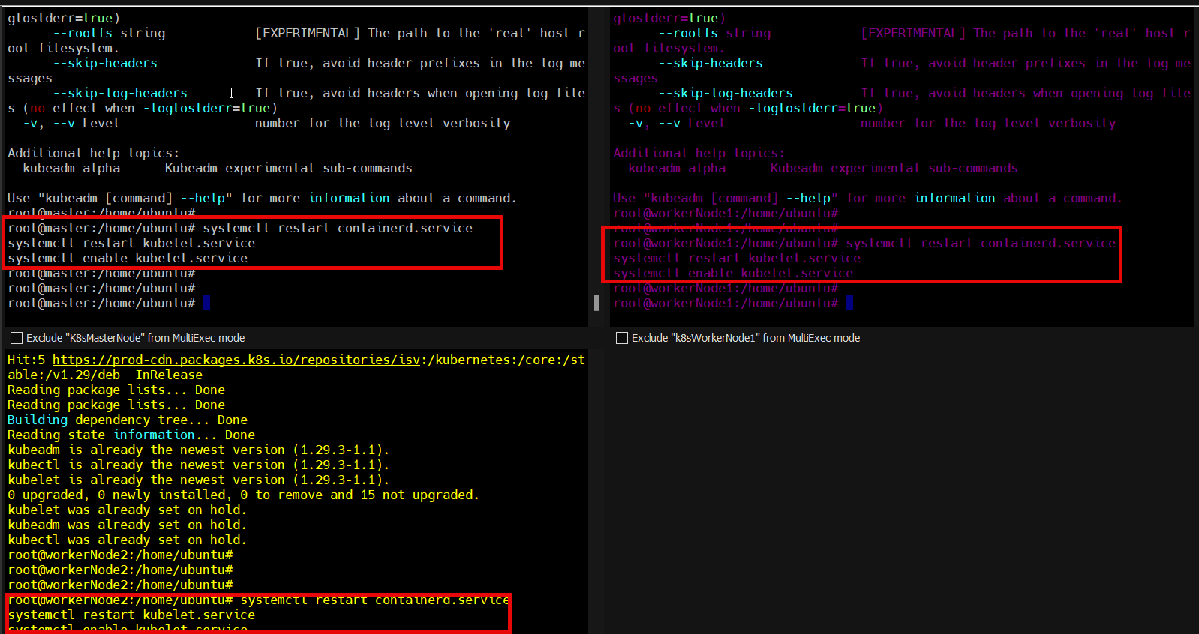

**Step11**: Check kubeadm version

|  |
| --- |
| **kubeadm version** |

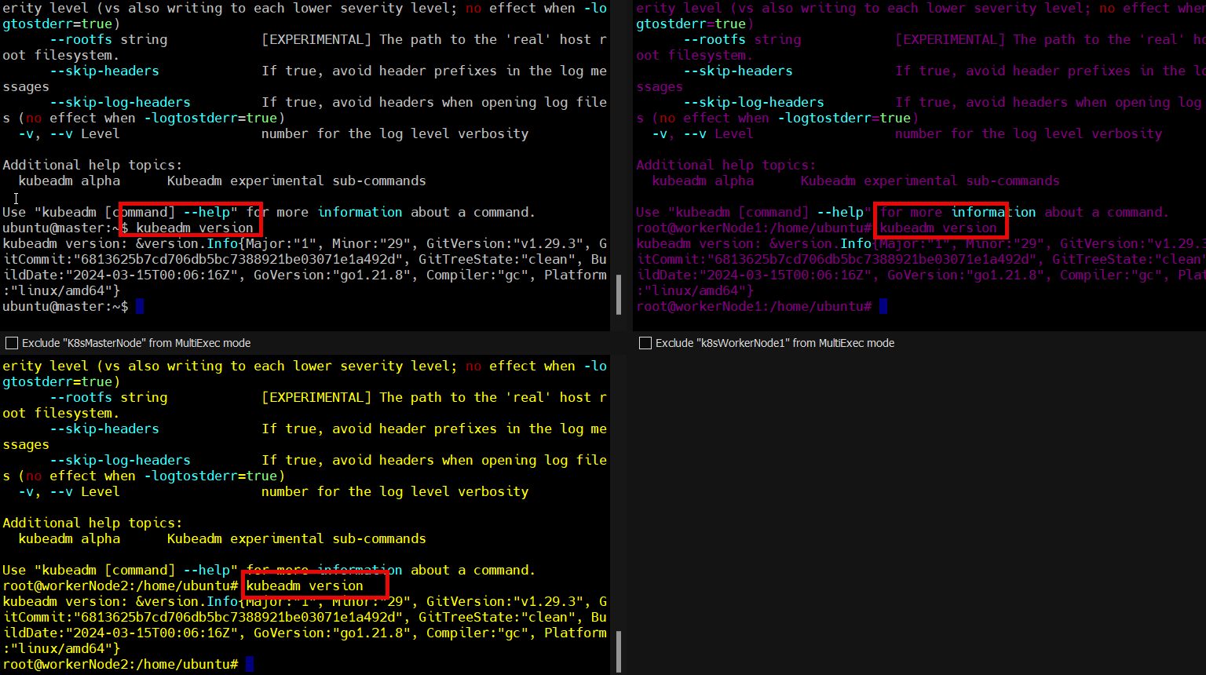

|  |
| --- |
| **kubeadm version: &version.Info{Major:"1", Minor:"29", GitVersion:"v1.29.2", GitCommit:"4b8e819355d791d96b7e9d9efe4cbafae2311c88", GitTreeState:"clean", BuildDate:"2024-02-14T10:39:04Z", GoVersion:"go1.21.7", Compiler:"gc", Platform:"linux/amd64"}** |

Now, we have completed the installation of the things that are needed on both nodes (Master and Worker). But in the next steps, we have to configure things only on the Master Node.

**Only on the Master Node**

**Step 13:**

Initialize the Kubernetes cluster and it will pull some images such as kube-apiserver, kube-controller, and many other important components.

|  |
| --- |
| **kubeadm config images pull** |

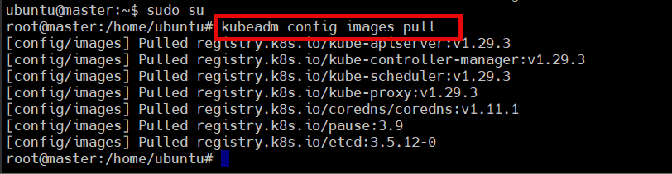

**Step 14:**

Now, initialize the Kubernetes cluster which will give you the token or command to connect with this Master node from the Worker node. At the end of this command, you will get some commands that need to run and at the bottom, you will get the kubeadm join command that will be run from the Worker Node to connect with the Master Node. I have highlighted the commands in the second next snipped. Please keep the kubeadm join command somewhere in the notepad.

|  |
| --- |
| kubeadm init |

kubeadm init --skip-phases=addon/kube-proxy

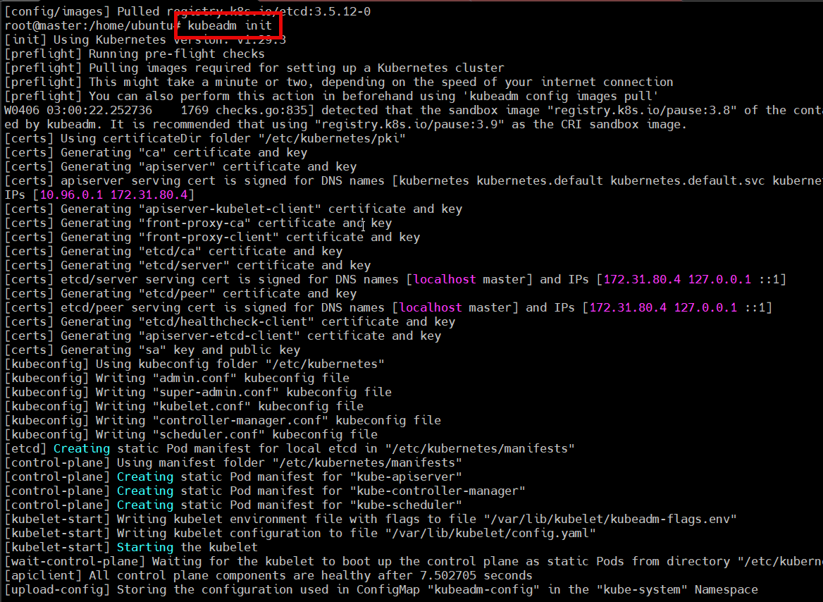

Keep the kubeadm join command in your notepad or somewhere for later.

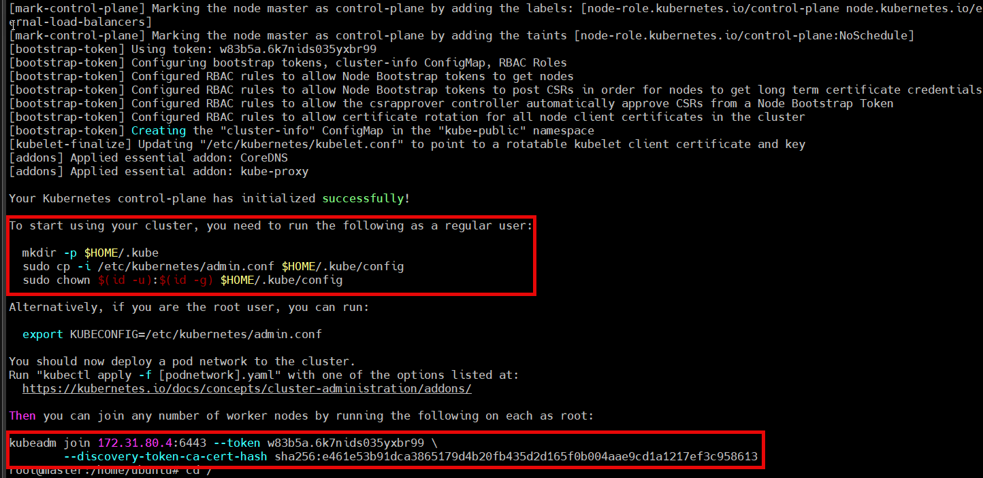

NOTE: kubeadm init has timeout of 5 min. so to avoid timeout error we are pulling images first

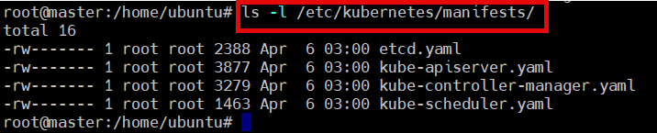

Step 15:

As you have to manage the cluster that’s why you need to create a .kube file copy it to the given directory and change the ownership of the file.

To start using your cluster, you need to run the following as a regular user:

|  |
| --- |
| **mkdir -p $HOME/.kube**  **sudo cp -i /etc/kubernetes/admin.conf $HOME/.kube/config**  **sudo chown $(id -u):$(id -g) $HOME/.kube/config** |

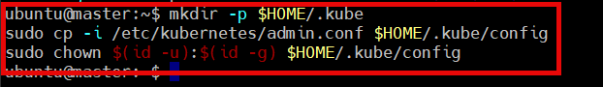

NOTE:

To resolve error we need to give permission to .kube file as mentioned in above steps

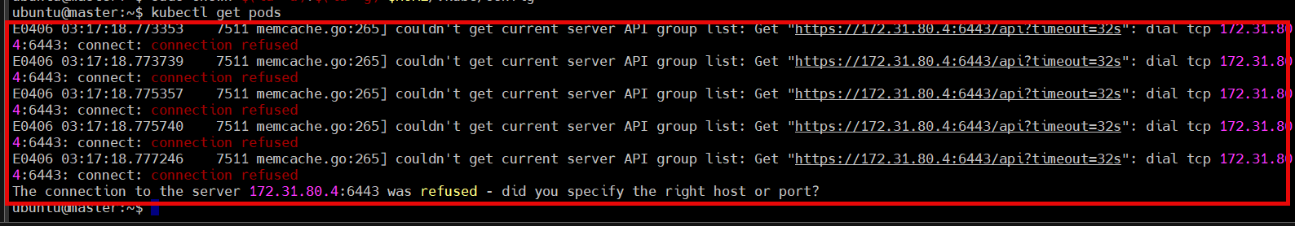

Step 16:

To install the network plugin on the Master node

|  |
| --- |
| **kubectl apply -f https://raw.githubusercontent.com/projectcalico/calico/v3.25.0/manifests/calico.yaml** |

kubectl apply -f <https://github.com/weaveworks/weave/releases/download/v2.8.1/weave-daemonset-k8s.yaml>

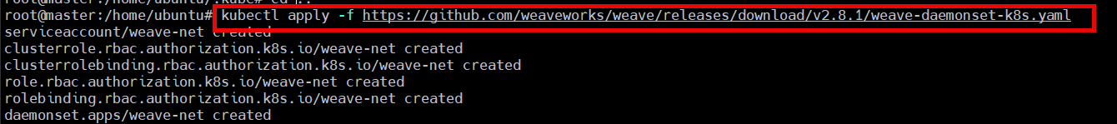

Step 17:

Verify the kubeconfig by kube-system which will list all the pods. If you observe, there are starting two pods that are not ready status because the network plugin is not installed.

|  |
| --- |
| **kubectl get po -n kube-system** |

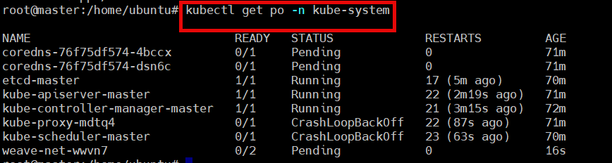

sudo ufw disable



The connection to the server 10.86.173.144:6443 was refused - did you specify the right host or port?

Starting containerd, did the magic for me.  
$sudo systemctl start containerd

To make it permanent, with server restart i enabled.  
$sudo systemctl enable containerd.service

After reboot it is working as well now. I think the issue is related to containerd being inactive in my case.

<https://discuss.kubernetes.io/t/the-connection-to-the-server-host-6443-was-refused-did-you-specify-the-right-host-or-port/552/26>

Step 18:

Verify all the cluster component health statuses

|  |
| --- |
| **kubectl get --raw='/readyz?verbose'** |

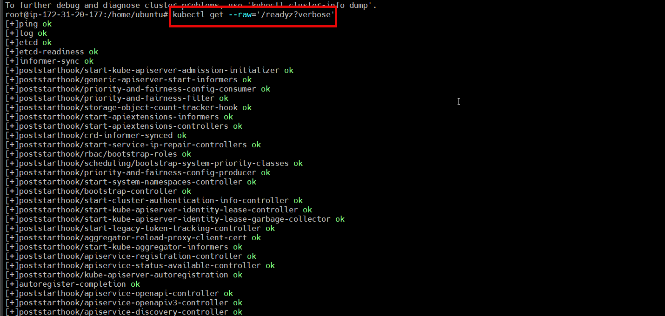

Step 18:

Check the cluster-info

|  |
| --- |
| **kubectl cluster-info** |



Step 20:

Now, If you run the below command, you will observe the two remaining pods are in ready status which means we are ready to bootstrap by our Workers Node or connect to the Master node through the Worker Node.

|  |
| --- |
| **kubectl get po -n kube-system** |

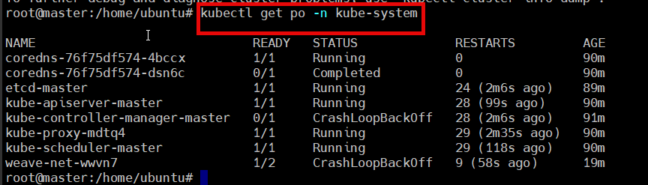

Step 21: Join Worker Nodes To Kubernetes Master Node

|  |
| --- |
| **kubeadm token create --print-join-command** |

To connect to other instance use join create command



Step 22:

Now, you have to run the command on Worker Node1. If you remember, I told you to keep the command somewhere in Step 14. Here you have to use your command because your token is different as well as mine.

Worker Node1

|  |
| --- |
| **kubeadm join 172.31.20.177:6443 --token rba96a.fx7l6h8brysrj1zk --discovery-token-ca-cert-hash sha256:f67c172e27af5d8da1920a2830188dfa45cba088003f76265e19c5707f1483a9** |

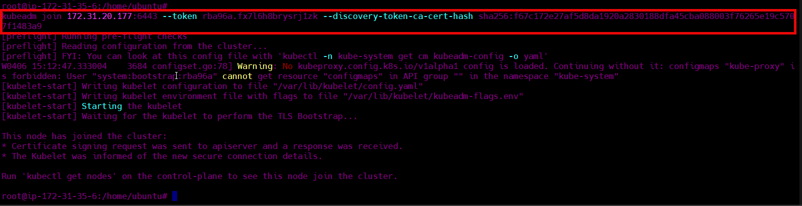

Step 22:

Follow the Step 21.

Worker Node2

|  |
| --- |
| **kubeadm join 172.31.20.177:6443 --token f4ccyn.3caw0dz92ua0rotb --discovery-token-ca-cert-hash sha256:f67c172e27af5d8da1920a2830188dfa45cba088003f76265e19c5707f1483a9 --v=5** |

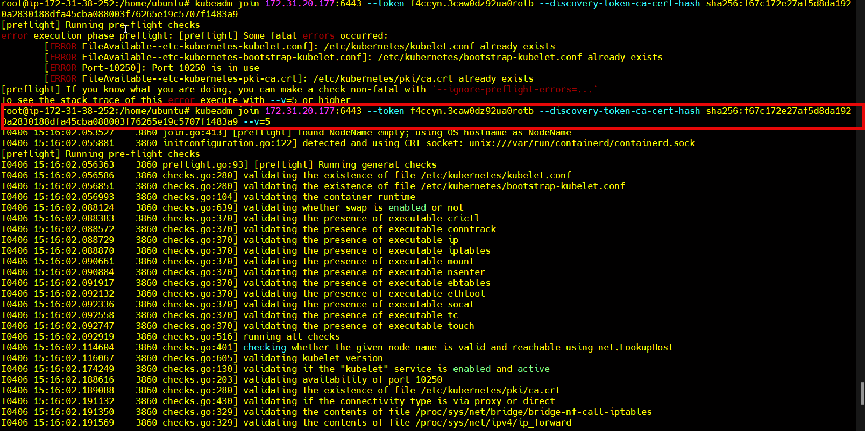

Step 23:

Now, from here all the commands will be run on Master Node only.

If you run the below command you will see that the Worker Nodes are present with their respective Private IPs and it is in Ready. status

|  |
| --- |
| **kubectl get nodes** |

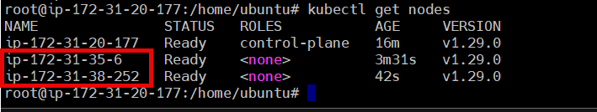

Here, we have completed our Setup of Master and Worker Node. Now let’s try to deploy a simple nginx pod on both worker nodes.

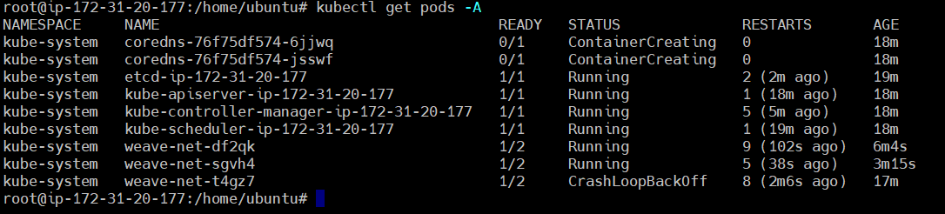

Step 23:

Run the command, which includes the deployment file to deploy nginx on both worker Node.

|  |
| --- |
| **cat <<EOF | kubectl apply -f -**  **apiVersion: apps/v1**  **kind: Deployment**  **metadata:**  **name: nginx-deployment**  **spec:**  **selector:**  **matchLabels:**  **app: nginx**  **replicas: 2**  **template:**  **metadata:**  **labels:**  **app: nginx**  **spec:**  **containers:**  **- name: nginx**  **image: nginx:latest**  **ports:**  **- containerPort: 80**  **EOF** |

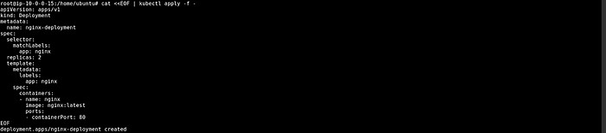

Step 24:

Run the command, which includes the deployment file to deploy nginx on both worker Node.

|  |
| --- |
| **cat <<EOF | kubectl apply -f -**  **apiVersion: v1**  **kind: Service**  **metadata:**  **name: nginx-service**  **spec:**  **selector:**  **app: nginx**  **type: NodePort**  **ports:**  **- port: 80**  **targetPort: 80**  **nodePort: 32000**  **EOF** |

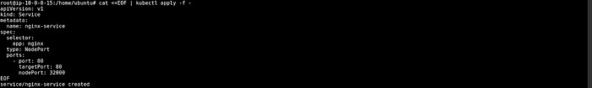

Step 25:

Now, check the pods by the below command and you can see that your pods are in running status.

|  |
| --- |
| **kubectl get pods** |



Step 26:

**On Worker Node1**

You can validate your deployment by copying the Public IP of your WorkerNode1 and adding a colon(:) with port(32000).

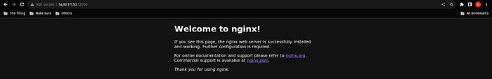

On Worker Node2

You can validate your deployment by copying the Public IP of your WorkerNode2 and adding a colon(:) with port(32000).

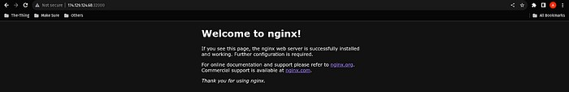

https://devopscube.com/setup-kubernetes-cluster-kubeadm/

# Setting up Minikube on Your Machine

## Introduction to Minikube

* **Minikube** is local Kubernetes, focusing on making it easy to learn and develop for Kubernetes. It creates a single node Kubernetes cluster
* **Minikube** provides a lightweight solution for developers to experiment, develop, and test Kubernetes applications locally.
* Available for **Linux, macOS, and Windows**
* Inbuilt support for **Metallb**, dashboard, storage provisioners etc
* Master node is untainted

## Why Set Up Minikube?

* Before we begin, you might be wondering why it’s essential to set up Minikube. Well, Minikube provides an excellent environment for learning and experimenting with Kubernetes without the need for a full-scale cluster. It’s perfect for developers and enthusiasts who want to get hands-on experience with Kubernetes in a controlled environment.

## Prerequisites

* 2 CPUs or more
* 2GB of free memory
* 20GB of free disk space
* Internet connection
* Container or virtual machine manager, such as: Docker, Hyperkit, Hyper-V, KVM, Podman, VirtualBox, or VMWare
* An AWS account (if you’re setting up on an AWS instance).

Let’s get started!

**Setting Up Minikube on AWS Instance**

Here, I am creating an EC2 Instance to set up minikube on the server. If you are comfortable setting up minikube on your local then feel free to jump on the minikube setup.

1. Enter the name of the machine and select the Ubuntu22.04 AMI Image.

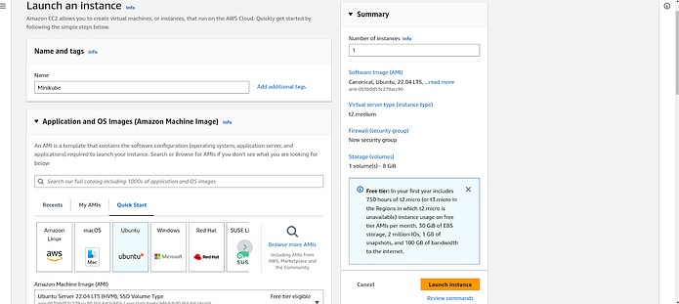

1. Make sure to select the t2.medium instance type as Master node 2CPU cores which is present in the t2.medium instance type.

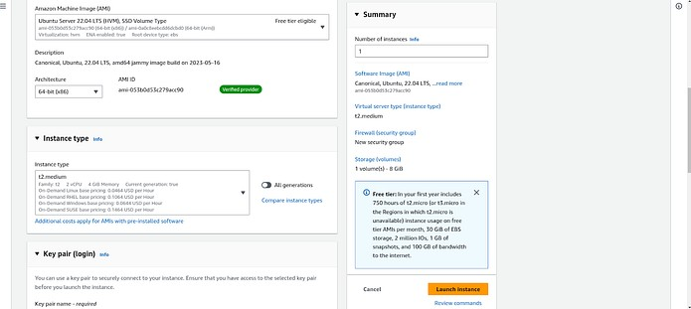

1. Create a new key pair and select the Private key file format according to your OS(For Windows select .ppk or for Linux select .pem).

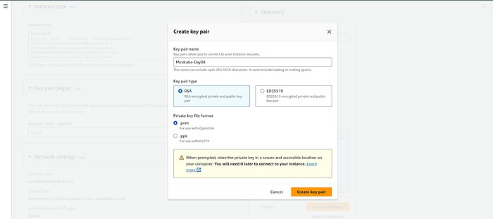

1. Open port 22 and rest you can leave it.

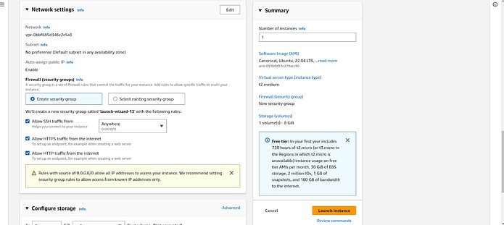

1. Now, go to your Downloads folder or where you have downloaded your pem file and change the permission by running the command ‘chmod 400 <Pem_file_name>



1. Now, connect your instance by copying the given command below.

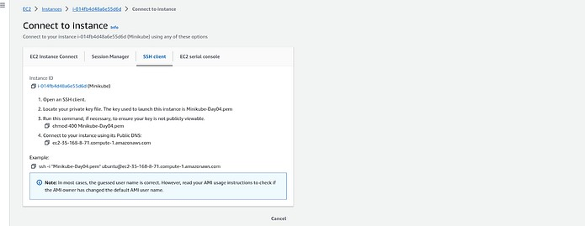

1. As you can see I logged in to the Instance.

**Step 1: Update System Packages**

First, update your package lists to ensure you are getting the latest version and dependencies.

|  |
| --- |
| **sudo apt update** |

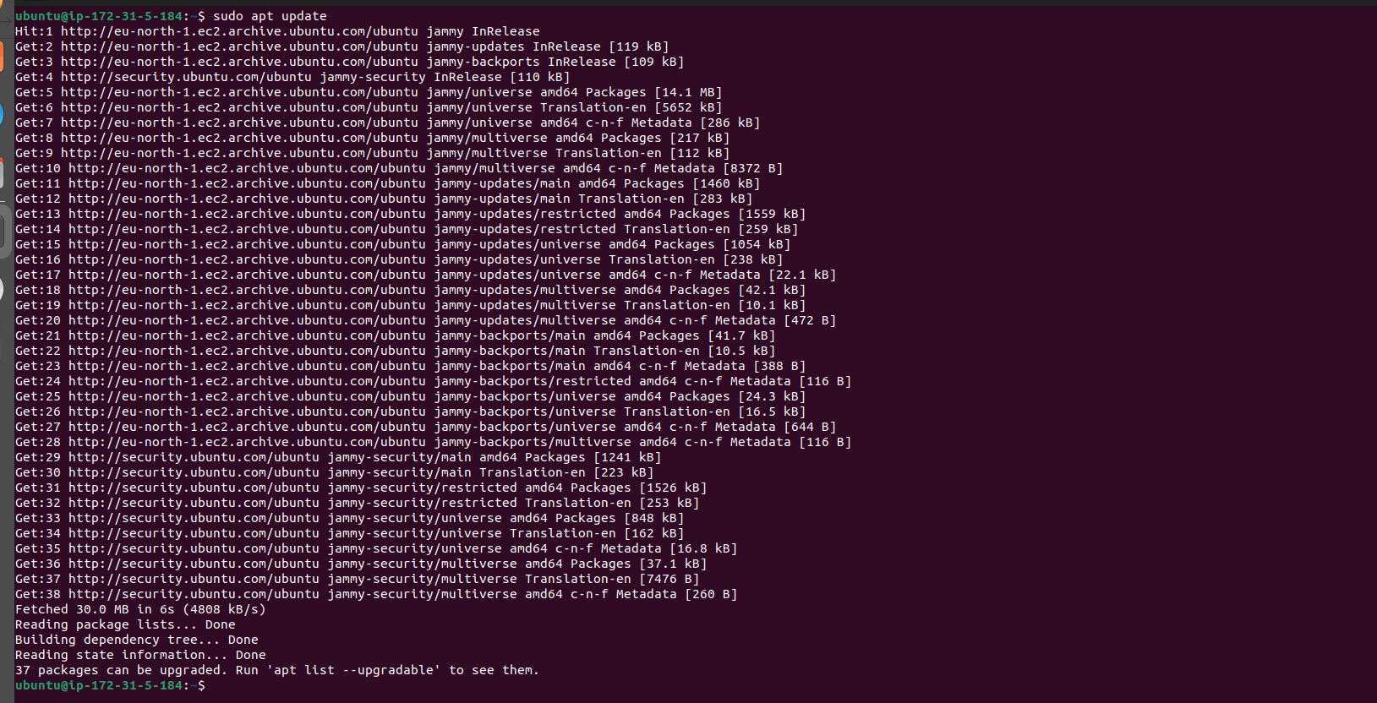

**Step 2: Install Required Packages**

Install some basic required packages.

|  |
| --- |
| **sudo apt install -y curl wget apt-transport-https** |

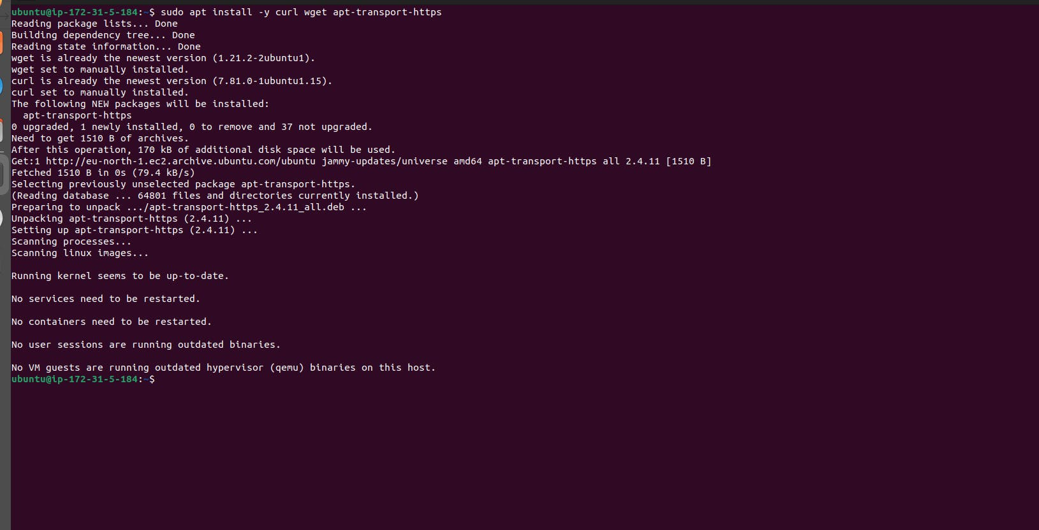

Step 3: Install Docker

Minikube can run a Kubernetes cluster either in a VM or locally via Docker. This guide demonstrates the Docker method.

|  |
| --- |
| **sudo apt install -y docker.io** |

Start and enable Docker.

|  |
| --- |
| **sudo systemctl enable --now docker** |

Add the current user to the docker group (To use docker without root)

|  |
| --- |
| **sudo usermod -aG docker $USER && newgrp docker** |

Now, logout (use exit command) and connect again.

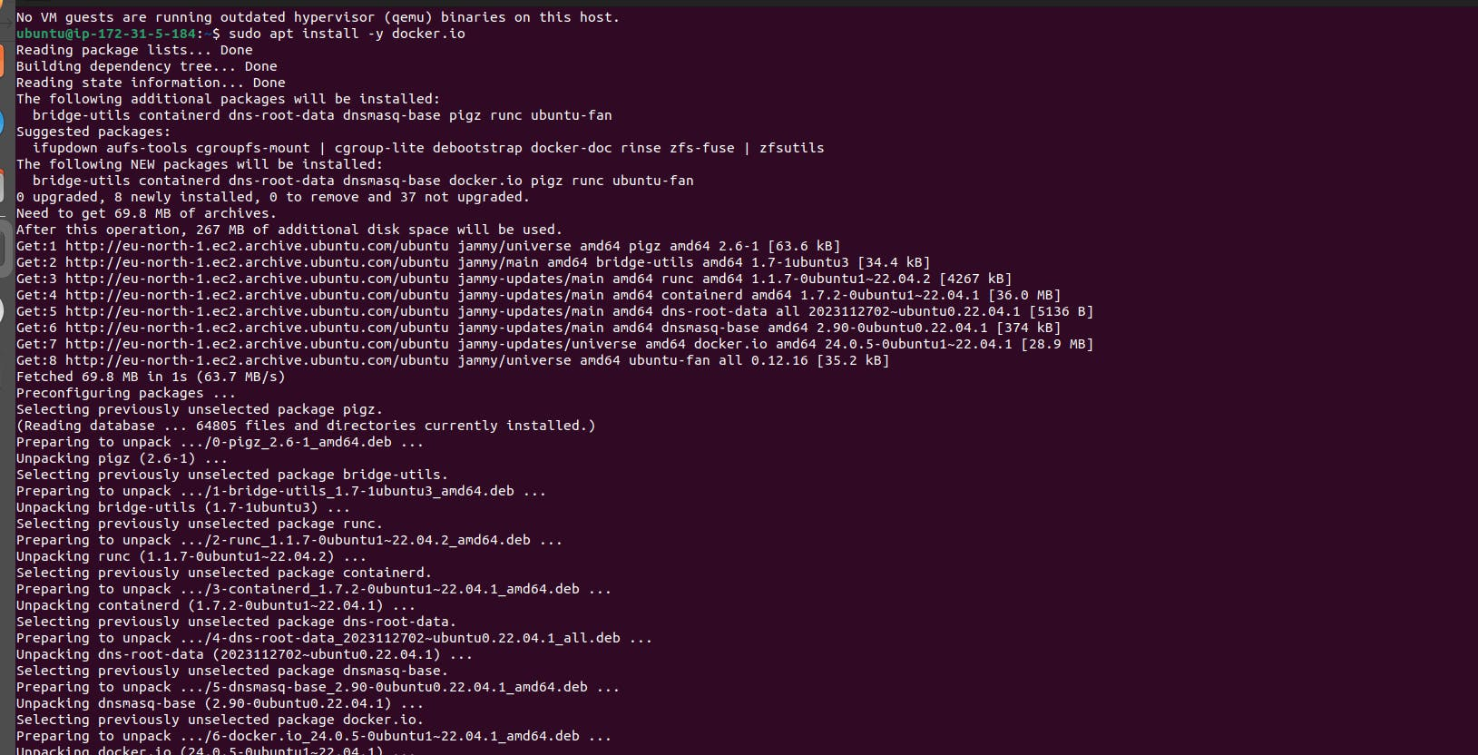



**Step 4: Install Minikube**

First, download the Minikube binary using curl:

|  |
| --- |
| **curl -LO "https://dl.k8s.io/release/$(curl -L -s https://dl.k8s.io/release/stable.txt)/bin/linux/amd64/kubectl"** |

Make it executable and move it into your path:

|  |
| --- |
| **chmod +x minikube**  **sudo mv minikube /usr/local/bin/** |

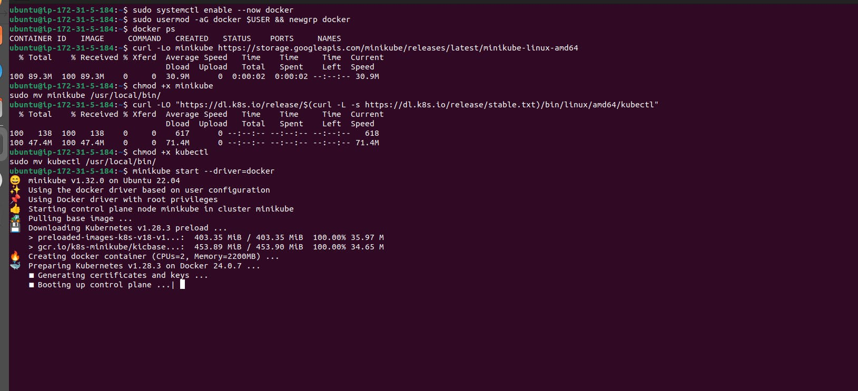

**Step 5: Install kubectl**

Download kubectl, which is a Kubernetes command-line tool.

|  |
| --- |
| **curl -LO "https://dl.k8s.io/release/$(curl -L -s https://dl.k8s.io/release/stable.txt)/bin/linux/amd64/kubectl"** |

Make it executable and move it into your path:

|  |
| --- |
| **chmod +x kubectl**  **sudo mv kubectl /usr/local/bin/** |

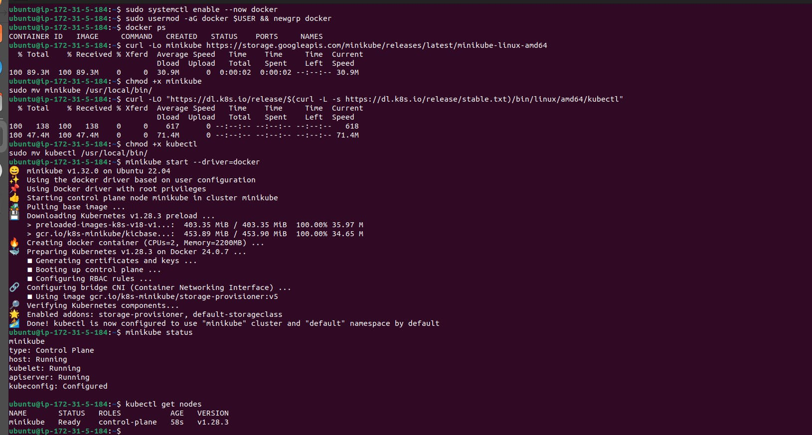

**Step 6: Start Minikube**

Now, you can start Minikube with the following command:

|  |
| --- |
| **minikube start --driver=docker** |

This command will start a single-node Kubernetes cluster inside a Docker container.

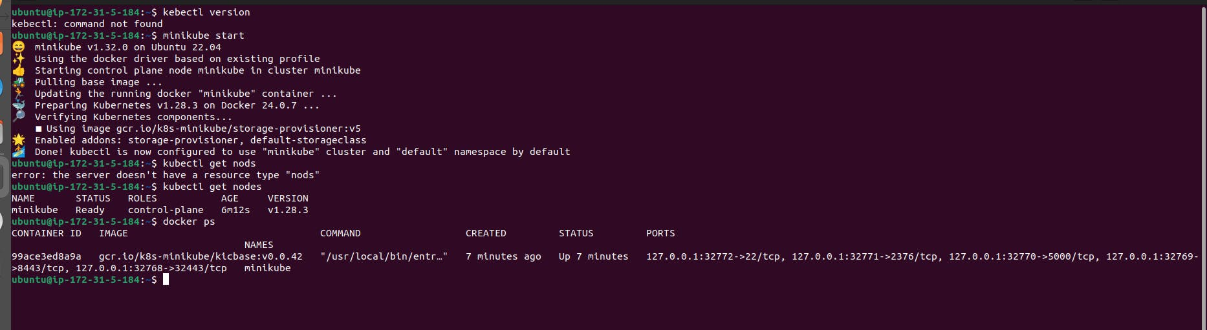

**Step 7: Check Cluster Status and Enter Minikube Container**

Check the cluster status with:

|  |
| --- |
| **minikube status** |

You can also use kubectl to interact with your cluster:

|  |
| --- |
| **kubectl get nodes** |

After confirming that the Minikube cluster is running and the components are operational, you can enter the Minikube Docker container to verify the installed components. Here's how you can do it:

1. List Docker containers to find the Minikube container ID:

|  |
| --- |
| **docker ps** |

Note the container ID of the Minikube container.

1. Enter the Minikube container using the following command:

|  |
| --- |
| **docker exec -it <container_id> bash** |

Replace <container_id> with the actual container ID you noted earlier.

1. Once inside the container, you can run commands to verify the installed components, such as etcd, kube-scheduler, etc. For example:

|  |
| --- |
| **kubectl get pods --all-namespaces** |

This command will show all the pods running in the Kubernetes cluster.

1. You can also interact with the Kubernetes cluster from within the container, for example:

|  |
| --- |
| **kubectl run my-nginx --image=nginx:latest** |

This command will deploy an Nginx pod in the Kubernetes cluster.

1. To exit the container, simply type exit.

By following these steps, you can verify that all the necessary components are installed and operational within the Minikube Docker container.

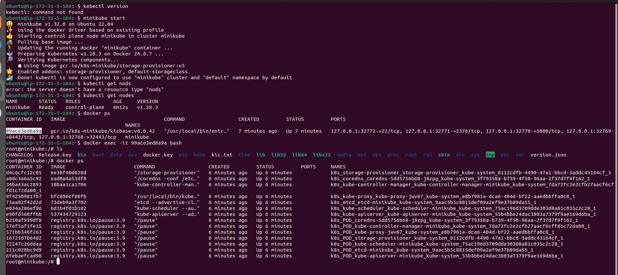



**Step 8: Stop Minikube**

When you are done, you can stop the Minikube cluster with:

|  |
| --- |
| **minikube stop** |

Optional: Delete Minikube Cluster

If you wish to delete the Minikube cluster entirely, you can do so with:

|  |
| --- |
| **minikube delete** |

That's it! You've successfully installed Minikube on Ubuntu, and you can now start deploying Kubernetes applications for development and testing.